TETZAVEH (you will command)

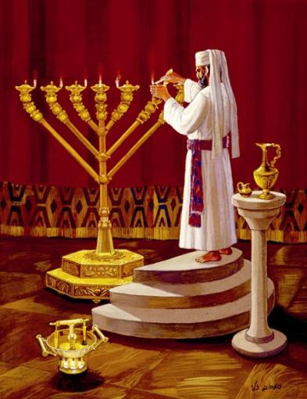

Question: What is different about this Torah portion? This is the only portion in the Torah since Moses' birth in which Moses' name does not appear (with the exception of the book of Deuteronomy, which consists wholly of a first-person narrative spoken by Moses). The reason for this is that, [when the people of Israel sinned with the Golden Calf, Moses returned to יהוה and said, This people have sinned a great sin and have made them gods of gold. Even now, if you will forgive their sin and if not, blot me, please, out of your book which you have written. And יהוה said to Moses, whoever has sinned against Me, I will blot out of My book (Exodus 32:31-33). Moses was prepared to forgo mention of his name in the Torah for the sake of his people. This was realized in this portion of scripture, since the reprimand of a righteous person, even if made conditional on an unfulfilled stipulation, always has some effect. Chumash

Question: What does this Torah portion deal with? This Torah portion deals with the Kohanim, their selection, their garments, and the inauguration service by which they and their offspring would become confirmed for all time as the special ministers of יהוה. Chumash

Exodus 27:20 וְאַתָּה And you will command אֶת־ Children of Israel that they bring you pure olive oil beaten for the light, so that the lamp will burn continuously. 21 In the Tabernacle of the Congregation outside the veil, which is in front of the testimony, shall order אֹתֹו it (him), Aaron and his sons will keep it burning from evening to morning before יהוה: it will be a statute forever to their generations מֵאֵת from the Children of Israel. C-MATS

Question: What does the word “command” mean in this verse? The word tetzaveh, "to command”, also means "to connect" and "to bond”. Thus the verse can also be read as יהוה saying to Moses: "And you shall bond with the Children of Israel”. For every Hebrew soul has at its core a spark of the soul of Moses, and we should bond with those who walk in the ways of יהוה. Chumash

Question: How was the oil for the Menorah made? The oil was made by pressing each olive gently until only one drop of pure oil emerged. Afterwards, the olives could be crushed and the remaining oil used for meal–offerings. Chumash

Question: What do the pressed (crushed) olives symbolize? Just as the olive yields light only when it is pounded, so are man's greatest potentials realized only under the pressure of adversity. Chumash

Question: How can we crush others to bring light? When one speaks crushing words of rebuke, it must be with the sole purpose of enlightening, illuminating, and uplifting one's fellow brother. Never humiliate and break a fellow-brother. Chumash

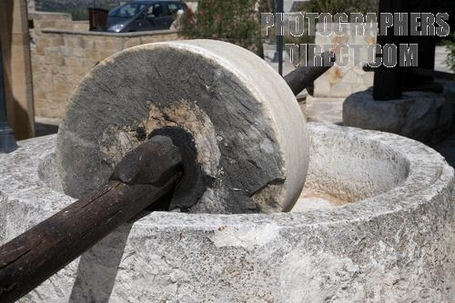
Mill to crush olives

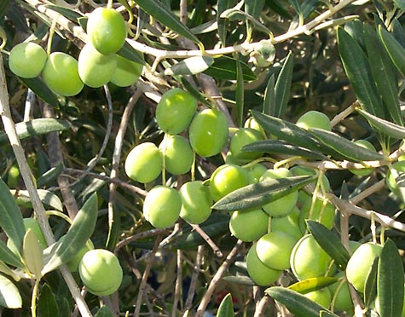
Olive tree
Question: What can we learn from the oil that was used in the Menorah? Sometimes the things that knock us down are exactly the things that lift us up. The pure oil that fueled the special lights of the giant menorah in the Tabernacle only came from the olives after they were knocked down, beaten, crushed, and pressed hard. We can learn a lesson from here that when it comes to us, the things in our lives that may make us feel crushed and knocked down can, if we look at them right, also bring the best out of us and ‘light us up' like never before.



Exodus 28:1 וְאַתָּה And you bring near אֶת־ Aaron, your brother וְאֶת־ and his sons אִתֹּו with him from among the Children of Israel, that he may minister to Me in the priest’s office, Aaron and his sons, Nadab and Abihu, Eleazar and Ithamar. 2 And you will make consecrated garments for Aaron, your brother, expressing glory and beauty. C-MATS
Question: What did the priestly garments signify to the Israelites? The garments were for the glory of יהוה and to lend splendor to the High Priest as the teacher of the nation, so that he would be revered by the tribes whose names he bore on his breast and shoulders. Chumash

Question: What can be learned from this symbolism of wearing sacred garments? The priest could perform the service only in garments indicating the sacred nature of what they were doing suggests also that we should pray or involve ourselves in the performance of other commandments- our own service to יהוה-should take care to dress and conduct ourselves with dignity and respect to the One before Whom we stand. Chumash

Discuss: On Sabbath and other feast days, should we dress in our best clothes and appear before יהוה clean to honor Him? Should our conduct at the Sabbath table and other feast days honor יהוה and show respect for Him? We should always remember that we are “priests” and minister to יהוה daily in everything that we say and do.

Question: What do the garments of Aaron represent? These garments are set-apart and represent את Yahusha Messiah clothed as our High Priest. Starting in Exodus 28:1, we see the את in front of Aaron's name in regard to him ministering in the office of the high priest before יהוה Father, just as Yahusha stands for us before יהוה in the heavenly Temple. C-MATS

Exodus 28:3 וְאַתָּה And you will speak to all who are wise hearted craftsmen, who I have filled with the spirit of wisdom, that they may make אֶת־ garments for Aaron to consecrate him, so that he may minister to Me in the priest’s office. 4 And these are the garments which they will make; a breastplate, an ephod, a robe, a broidered coat, a turban and a girdle (sash): and they will make consecrated garments for Aaron, your brother and his sons that he may minister to Me in the priest’s office. C-MATS

Question: What did the High Priest wear on his feet? He walked in bare feet because he was standing on Sacred Ground. Chumash

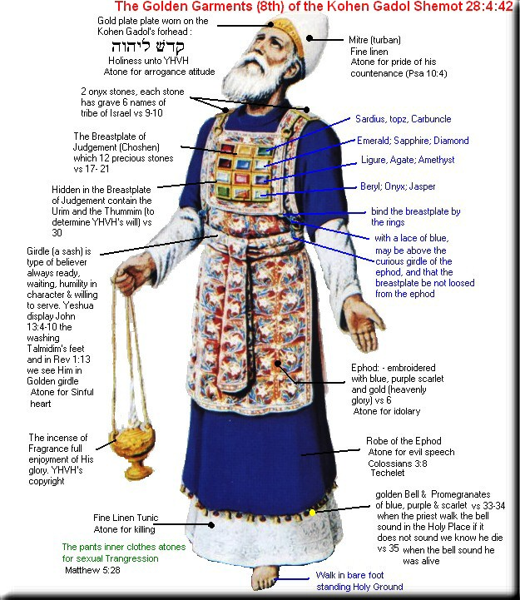
Question: What is the function of each of the priestly garments?
Robe- atone for evil speech (slander)
Tunic- atone for killing (bloodshed)
Ephod- atone for idolatry
Breastplate of Judgment- atoned for erroneous decisions made by courts of judgment
Turban- atone for pride of his countenance
Sash- atone for sinful heart (impure meditations of the heart)
Head plate- atone for arrogance attitude
Linen breeches (shorts) - atone for sexual transgression

Question: In what order did the priest put on his garments?
- Linen breeches- to cover his nakedness
- Tunic- made of fine linen and worn directly on the skin and it was knitted in such a way that there were box-like indentations in the material, which looked like the setting of jewels
- Robe- made entirely of blue wool, a color that reminiscent of heaven and which symbolizes יהוה’s heavenly Throne of Glory. Hanging around the Robe’s hem were 72 pomegranate shaped tassels and among the pomegranates were 72 golden bells, each with a ringer.
- Ephod- worn over the tunic and robe. It was similar to an apron that he wore on his back, coming around in front over his hips and partly over his stomach. It extended from below the rib cage to his ankles. It was worn over the Robe.
- Sash- a single woven piece of material tied in front between his waist and heart to secure the Ephod.
- Breastplate of Judgment- made of the same material as the Ephod and bearing the 12 gemstones, each in its own setting, with the names of the tribes engraved on the stones.
- Turban- made of fine linen and worn on the head
- Head plate- a narrow gold plate, two fingerbreadths wide upon which were inscribed the words “Consecrated unto יהוה”.

Exodus 28:5 And they will take אֶת־ gold, וְאֶת־ and blue, וְאֶת־ and purple וְאֶת־ and scarlet yarn וְאֶת־ and fine linen. 6 And they will make אֶת־ the ephod (ritual vest) of gold, blue, purple, scarlet yarn and fine woven linen with skilled work by a craftsman. C-MATS

Question: How was the yarn made to make the ephod? The yarn consisted of five different materials. The workers flattened the gold into a sort of thin plate and cut cords out of them and spun them. Six strands of blue wool and one of gold were twisted together to make a seven-strand thread. The same was done with purple wool, scarlet wool, and linen. Six strands of each were twisted with one strand of gold. Then all four seven-strand threads were twisted together to make a thick thread of 28 strands. Chumash

Exodus 28:7 It will have the two shoulder pieces joined at the two edges, so it will be joined together. 8 And the decorated girdle (sash) of the ephod will be of the same workmanship and materials; gold, blue, purple and scarlet yarn and fine woven linen. 9 And you will take אֶת־ two onyx stones and engrave on them the names of the Children of Israel: 10 Six of their names on הָאַחַת the one stone, וְאֶת־ and names of the other six on the other stone, in order of their birth.
Exodus 28:11 An engraver will engrave אֶת־ two stones with the names of the Children of Israel: he will engrave the stones like the engravings of a signet (seal) and set אֹתָם them in settings of gold. 12 And you will put אֶת־ the two stones upon the shoulders of the ephod as a memorial to the Children of Israel: and will bear Aaron אֶת־ their names before יהוה upon his two shoulders for a memorial. C-MATS

Question: Why was the stones placed on the shoulders of the high priest? The stones were a memorial for the sons of Israel to יהוה to remember the promises to His people. Chumash

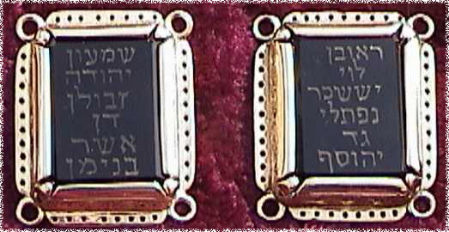
Onyx stones on the shoulders of the high priest with the names of 6 tribes on each one

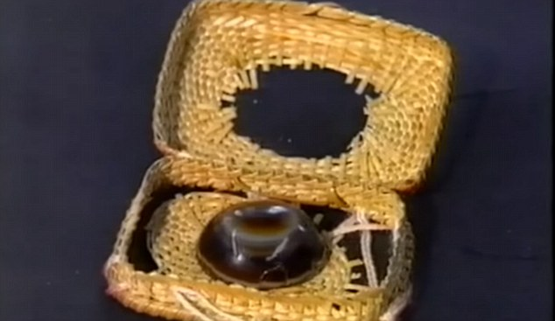

Lost stone found: A small onyx stone, claimed to be given to a Knight Templar over 1,000 years ago and handed down through one family from generation to generation was found in a family from South Africa. Experts believe this is one of two sardonyx stones fixed in gold settings on the shoulders of the High Priest. If this is so, contained within it is the power of prophecy and it may play an important role in returning the Priestly Caste to serve in the Temple. Read more at
https://www.breakingisraelnews.com/75645/bin-exclusive-lost-stone-high-priests-prophetic-breastplate-thought-found-incredible-journey/#pAccwFQ44GLFTUa0.99

Exodus 28:13 And you will make settings of gold squares; 14 And two chains of pure gold, you shall make אֹתָם them, twisted like cords and fasten אֶת־ the chains to the settings. 15 And you will make the breastplate of judgment with skilled work of a craftsman; you will make it like the work of the ephod (ritual vest); of gold, blue, purple and scarlet yarn and fine woven linen shall you make אֹתֹו it (him). 16 It will be doubled and square; a hand span will be the length and a hand span will be the width. 17 And you will set in it settings of four rows of stones, the first row will be a ruby, a topaz and a carbuncle. C-MATS
Question: What is a carbuncle? A carbuncle is an archaic name given meaning coal, in reference to the color of burning coal; in this sense, a carbuncle is usually taken to mean a gem, particularly a deep-red garnet, unfaceted and convex. Chumash
Exodus 28:18 And the second row will be an emerald, a sapphire and a diamond. 19 And the third row an amber, an agate and an amethyst. 20 And the fourth row a beryl, an onyx and a jasper: they will be set in gold settings. 21 And the stones will be engraved with the names of the twelve Children of Israel like the engravings of a signet (seal); every one of the stones representing one of the twelve tribes. C-MATS

Question: How were the stones placed on the Breastplate? Moses does not tell us the order that the stones should be placed on the breastplate. Most scholars say that the stones were arranged on the breastplate by birth order from right to left (as Hebrew reads). Some suggest that it may be by encampment of the tribes. It is almost impossible to translate the names of the stones with any accuracy. Bible translators had no clue as to what many of the stones names referred to. For example, the fourth stone is called "emerald" in the King James version, "carbuncle" in the Greek translation (Septuagint), "turquoise" in the New American Standard version, and "garnet" in Strong's dictionary. After much research, these are the names of the stones known today.

Zebulon Issachar Judah
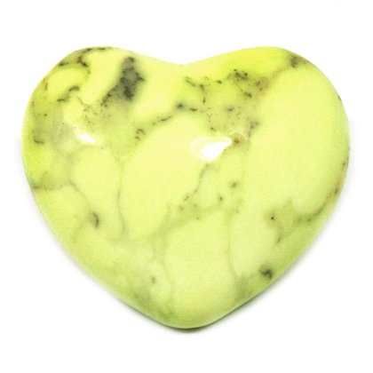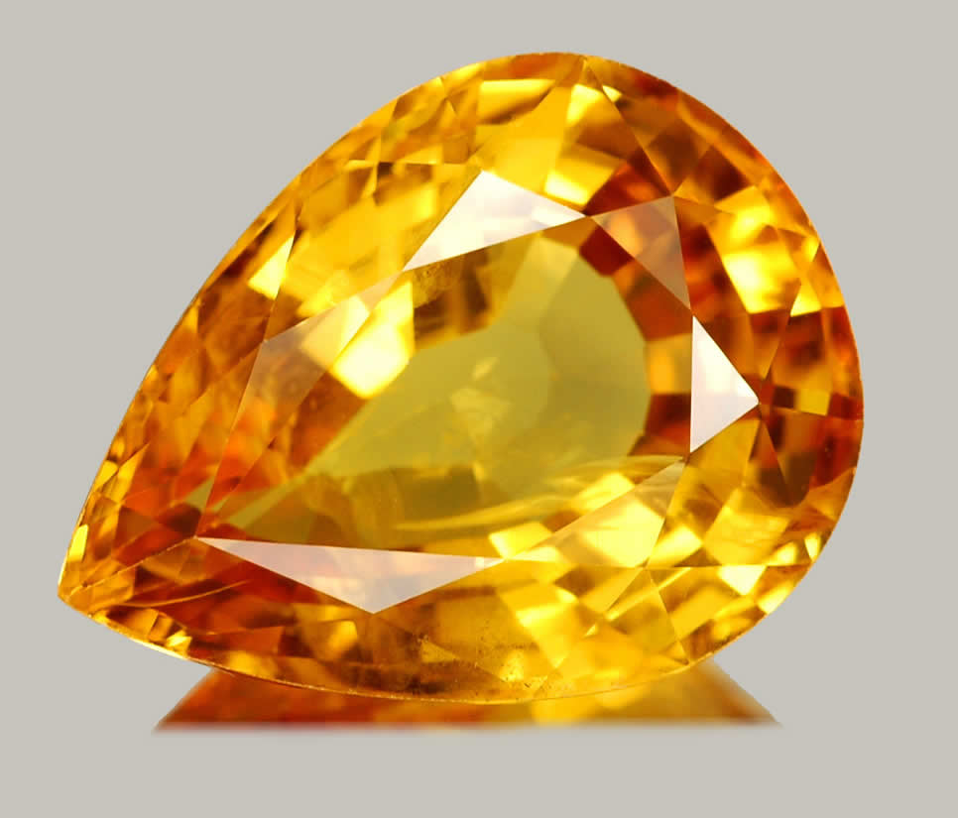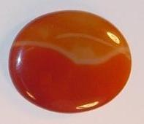
Chrysoprase Topaz Sard

Gad Naphtali Dan
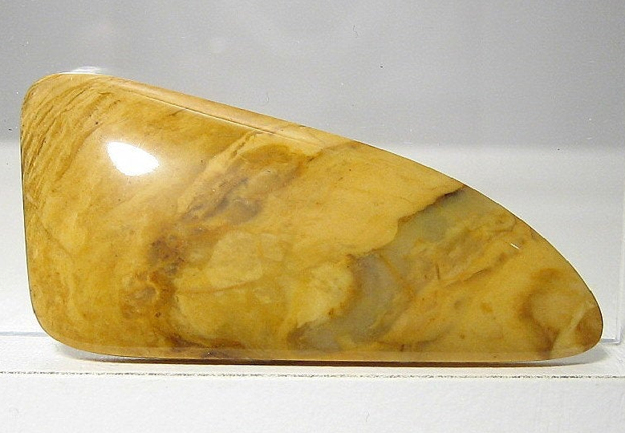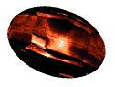
Jasper Chalcedony Jacinth

Levi Simeon Reuben
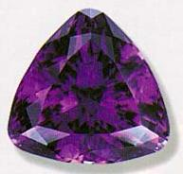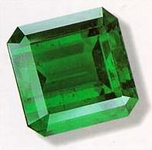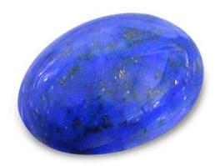
Amethyst Emerald Lapis Lazuli

Benjamin Joseph Asher
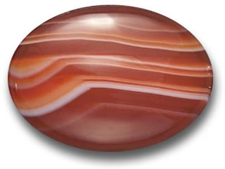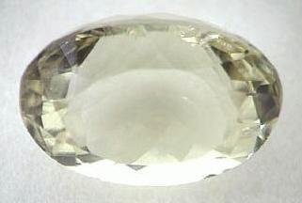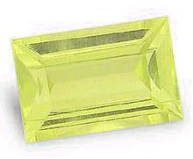
Sardonyx Beryl Chrysolite

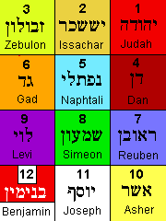

Discuss: The classic constellations were associated with colors, some of which have been explicitly recorded from antiquity. Do the colors of the tribes correlate with the constellations and the stones on the breastplate? Do birth stones come from the stones of the tribes?

Hebrew | Foundation | Color | Constellation | Tribe
1. Odem | Sard | Red | Lion | Judah
2. Pitdah | Topaz | Tan | Crab | Issachar
3. Bareqeth | Chrysoprase | Yellow Green | Ram | Zebulon
4. Nophek | Jacinth | Red Black | Scorpion | Dan
5. Sappiyr | Chalcedony | Light Blue | Maiden | Naphtali
6. Yahalom | Jasper | Orange | Archer | Gad
7. Leshem | Lapis Lazuli | Royal Blue | Water Bearer | Reuben
8. Shebuw | Emerald Quartz | Green | Sea Goat | Simeon
9. Aclamah | Amethyst | Purple | Fishes | Levi
10. Tarshish | Chrysolite | Yellow | Scales | Asher
11. Shoham | Beryl | White | Bull | Joseph
12. Jashepheh | Sardonyx | Red & White | Twins | Benjamin

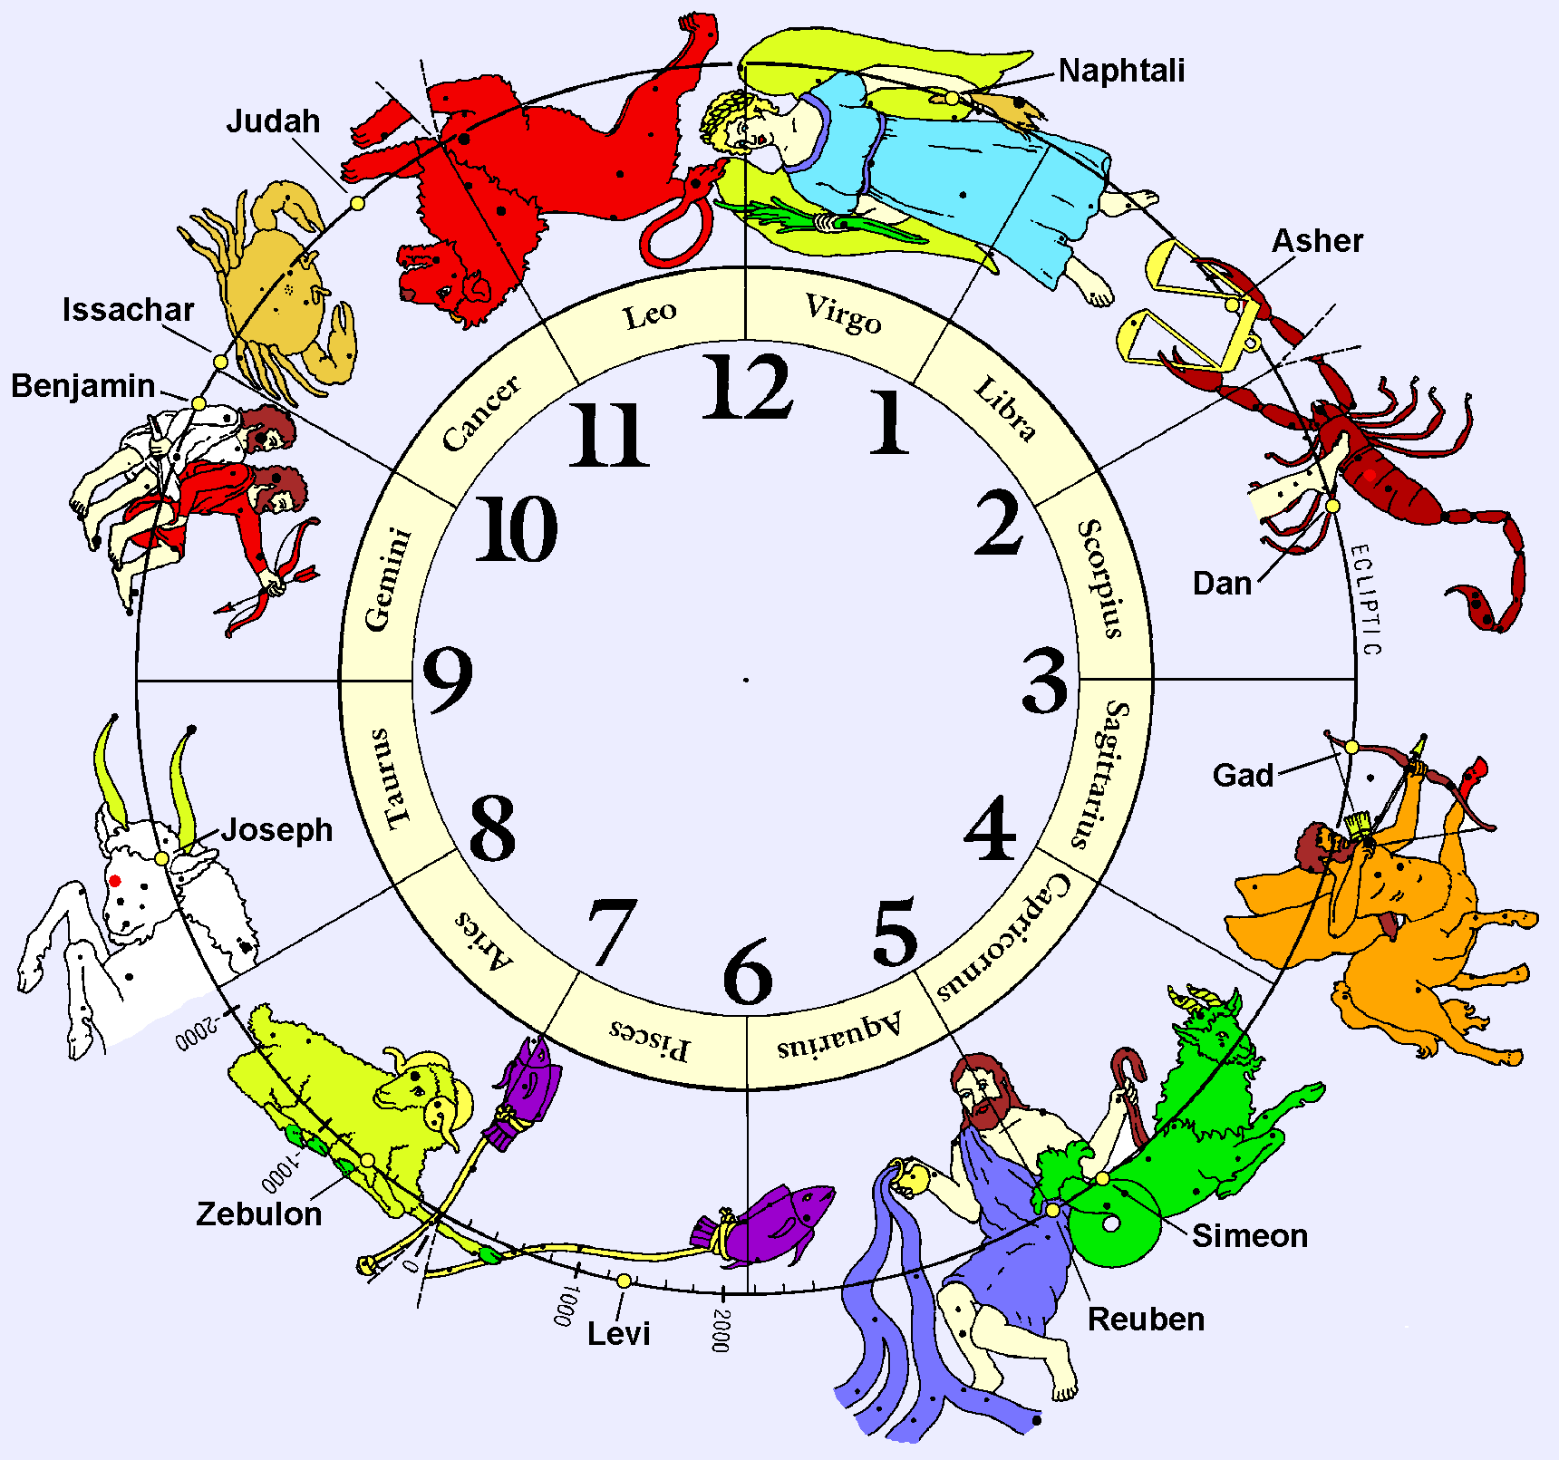
The Star Constellations in the proposed colors

This is interesting reading from astronomer John Pratt that you may want to investigate. http://www.johnpratt.com/items/docs/lds/meridian/2005/12stones.html
Pratt also proposes that the gospel story is told in the constellations. http://www.johnpratt.com/items/docs/lds/meridian/2005/zodiac.html
Question: Did you know that stones hold sounds? Y'hoshua 24:27 And Y'hoshua said to all the people, Behold, הַזֹּאת this stone shall be a witness against us; for it has heard את־ all the words of יהוה which He spoke to us: it shall be therefore, a witness against you, lest you deny your Elohim. David Van Couvering says that stones actually hold sounds in them. When you speak words that come out of your mouth, they become embedded in the stones (stay locked in). The sound molecules go into the rock displacing another molecule that comes out. If we could ever figure out how to get the sound out of the rock, we could hear a lot of very old conversations. Is this why Solomon did not want the sounds from iron mixed with the sounds of the blood of the sacrifice crying out in the temple? As you know יהוה had said that Abel's blood cried out from the ground. Jerusalem limestone is white as snow and that is the stone that was used to build the temple.

Question: Do stones have spiritual values? Some rabbis found spiritual values and practical influences of the stones of the breastplate besides their holy task. Rabbi Bechai’ei said that each of the stones attracted heavenly strength and in the Midrash in Bereshit Raba 14 it is written that each of the stones receives strength from heaven. The twelve stones matched the attributes of the tribes.

Question: Did the 12 stones have healing powers? There is a bit of controversy over whether or not the gemstones actually have healing qualities. Ancient cultures like our First Nations’ cultures believe that they do and these traditions go back centuries. Native healers wore medicine pouches around their necks and healing stones were in them. These tribes of people were more connected to the Earth and their spirituality than most westerners are today. Many people have found stones to heal and bring energy to their body. This is an area of study that may have been lost and could be a source of help for us in the future.

Exodus 28:22 And upon the breastplate you will make braided chains of pure gold. 23 And upon the breastplate you will make two rings of gold and will put אֶת־ two rings on the two ends of the breastplate. 24 And you will put אֶת־ two braided chains of gold in the two rings which are on the ends of the breastplate. 25 וְאֵת and the other two ends of the two braided chains you will fasten in the two settings and put them on the front shoulder pieces of the ephod. 26 And you will make two rings of gold and put אֹתָם them on the two ends of the breastplate at its edge, which is in the inner side of the ephod. 27 And two other rings of gold you will put אֹתָם them low on the two sides of the ephod on the front part of the ephods shoulder pieces, near the seam, above the decorated girdle (sash) of the ephod. 28 And they will bind אֶת־ the breastplate by the rings to the rings of the ephod with a blue lace (cord), so that it may be above the decorated girdle of the ephod and the breastplate will not become loose from the ephod. 29 And Aaron will carry אֶת־ the names of the Children of Israel in the breastplate for judging upon his heart when he goes into the sacred place for a memorial before יהוה continually. 30 And you will put in the breastplate for judging אֶת־ the Urim וְאֶת־ and the Thummim; and they will stay on Aaron’s heart when he goes before יהוה: and Aaron will bear אֶת־ the judgment of the Children of Israel upon his heart before יהוה continually. C-MATS

By the wearing of the garments and the placement of the Urim and Thummim under the breastplate, the high priest actually bears the judgment of את Children of Israel before יהוה Father continually. The position of high priest is a direct reflection of את Yahusha our Messiah after the Order of Melchizedek according to Hebrews 5:6 “You are a priest forever after the order of Melchizedek.”
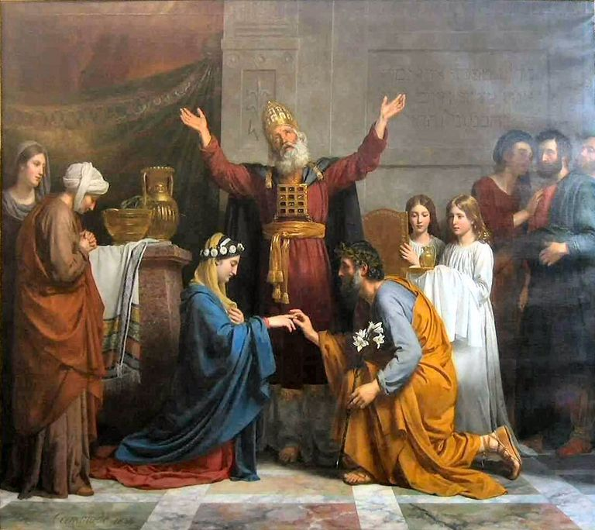
Wedding performed by the High Priest

Question: Where were the Urim and Thummim kept? The Breastplate was folded in half to form a pouch-like pocket and the Urim (OOR reem) and Thummim (THOOM meem) were kept in there. (Chumash)

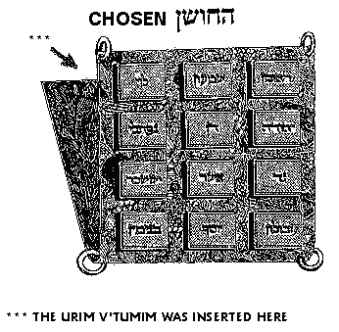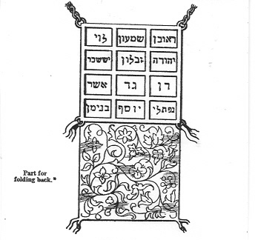

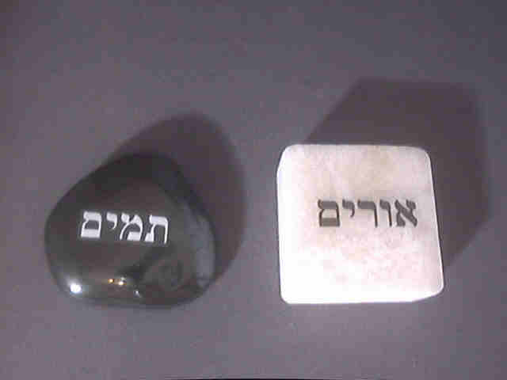

Question: What were the Urim and the Thummim? Urim is derived from the Hebrew for “light” or “to give light” and Thummim from “completeness”, “perfection”, “perfection, or “innocence”. In view of these derivations it is surmised by some scholars that the sacred lot may have had a twofold purpose in trial ordeals- Urim served to bring to light the guilt of the accused person, and Thummim to establish his innocence. Many references in the bible refer to casting lots, which would most probably be the Urim and Thummim. Proverbs 16:33 Into the lap is cast את־ the lot; but the whole disposing there is of יהוה. When King Saul did not follow the commands given to him by יהוה, the spirit departed from him. He then tried to get an answer by consulting the Urim. And when Saul inquired in ביהוה, יהוה did not answer him, neither by dreams, nor by Urim, nor by prophets. 1 Samuel 28:6. C-MATS
Question: What were the three ways that יהוה answered His people before He gave us His Spirit to dwell within us? יהוה usually answered His people: by dreams, by prophets and by Urim from the High Priest. King Saul wanted a yes or no answer and in this same passage you see the answer for Saul's inquiry. And Samuel said to Saul, Why have you disquieted me, to bring אתי me up? And Saul answered, I am very distressed; for the Philistines make war against me and Elohim is departed from me and answers me no more, neither by prophets, nor by dreams: therefore, I have called you, that you may make known to me what I shall do. 1 Samuel 28:15. C-MATS
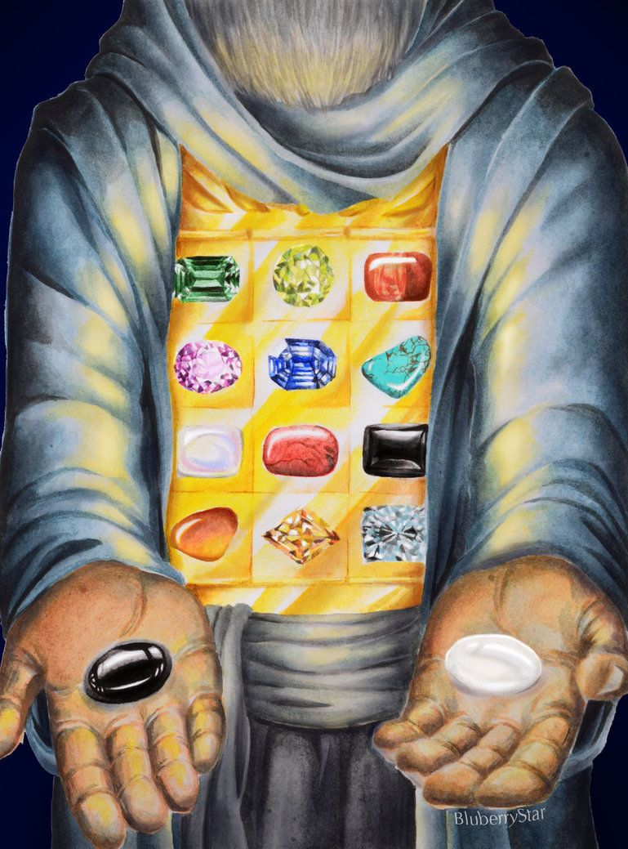
Question: How was the Urim and Thummim used? According to Ramban, there was more than one Name. This Name was called ‘Urim’ from the word ‘light’, because it would cause individual letters of the tribal names on the Breastplate to light up; and it was called Thummim from the word ‘completeness’, because, if read in the proper order, these luminous letters presented complete and true answers to the questions of national import that the High Priest would ask of יהוה.

The process of asking for Divine aid through the ‘Urim’ and ‘Thummim’ was done as follows: When a question of national importance arose, such as, for example, the question of whether or not to go to war – then, the king of Israel (or the commanding army officer) would ask this question of the High Priest. The Kohen יהוהal (High Priest) would stand facing the ark of testimony, and the questioner stood behind him, facing the High Priest’s back. The questioner did not speak aloud but posed his question quietly, to himself, like someone who prays in silence before His Creator. The High Priest enveloped by the spirit of Divine inspiration, gazed at the Breastplate and, by meditating upon the Holy names of יהוה, was able to receive the answer through a prophetic vision. The letters on the stones of the Breastplate would light up and shine forth with a bright luminous light to spell out the answer to the question. (The Holy Temple of Jerusalem, 1997, page 39, by Rabbi Chaim Richman)

Josephus Flavius – the great Jewish historian writes that the jewelled Stones in the Breastplate also shone brilliantly when Israel went forth into battle. This was considered as an auspicious sign for their victory. He writes as follows: “Yet will I mention what is still more wonderful than this; for Adonai declared beforehand, by those twelve gems which the High Priest bare on his breast and which were inserted into his breastplate, when they should be victorious in battle; for so great a splendour shone forth from them before the army began to march that all the people were sensible of Adonai’s being present for their assistance”. (Antiquities 3.8.9)

Question: When was the last time the Urim and Thummim was mentioned in the Scriptures? The last time the Urim and Thummim was mentioned in the Bible is in the Book of Nehemiah. The occasion concerns a group of men returning from their captivity in Babylon who could not identify their father's house or their lineage, or even whether they were of Israel. And these were they that went up from Tel-melah, Tel-harsha, cherub, Addon and Immer; but they could not show אֲבֹותָם their father’s houses, nor their seed, whether they were of Israel. Nehemiah 7:61 Some of them sought their listing by genealogy to no avail and hence they were excluded from the priesthood. These sought their register among those that were written in the genealogy, but it was not found: therefore, were they deemed polluted and put from the priesthood. And the governor said to them, that they should not eat of the most holy things, till there stood up a priest with Urim and Thummin. Nehemiah 7:64-65. C-MATS

Question: What happened to the Urim and Thummim? King Josiah realized that Israel would be conquered and fearing that the most sacred parts of the Temple would fall into profane hands, he removed the Urim and Thummim from the Breastplate and hid it and he also hid the Ark containing the Tablets, and the anointing oil. None of them were found during the period of the Second Temple. While their absence denoted a diminished degree of sacredness, it did not prevent the performance of the Temple service. It did mean that from that time onward, the High Priest could not present Israel’s urgent questions for יהוה’s response.
Discuss: Could it be that the Urim and Thummim would be restored in the Last Days and establish the ancestry of those returnees to Israel in the Second Exodus?

Exodus 28:31 And you will make אֶת־ the robe for the ephod entirely of blue. 32 And there will be a hole in the middle of it for the head: it will have a binding of woven work around the hole like a habergeon (coat of mail) so that it will not tear. 33 And on the hem of the robe you will make pomegranates of blue, purple and scarlet and bells of gold between them: 34 A golden bell and a pomegranate, a golden bell and a pomegranate, around the hem of the robe. C-MATS

Question: How should you enter the Presence of יהוה? יהוה hates one who enters his house suddenly--much more so his neighbor's house. Enter into his Presence quietly with thanksgiving. Chumash

Exodus 28:35 And Aaron will wear it to minister: and his sound will be heard when he goes into the sacred place before יהוה and when he comes out, so that he will not die. C-MATS

Question: What keeps the priest from not dying? If he has on the priestly garments, he will not be liable to death, but if he enters when he is lacking one of these garments, he is liable to death by the hands of Heaven. Chumash

Exodus 28: 36 And you will make a plate of pure gold and engrave upon it, like the engravings of a signet (seal), CONSECRATED TO ליהוה. 37 And you will put אֹתֹו it (him) on a blue lace (cord) attached to the front of the turban. C-MATS

Question: How was the Head-plate attached to the Turban? The Head-plate was secured to Aaron’s forehead by means of blue cords that tied together at the back of his head. Chumash

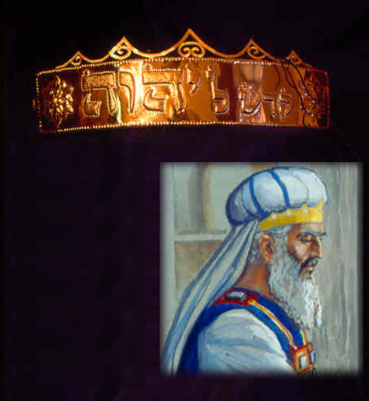
(Notice: Two stones that were engraved with the names of the sons of Israel on them were placed on the High priest’s shoulder so יהוה was always aware of His promises.)

Exodus 28:38 And it shall be upon Aaron’s forehead, that may bear Aaron אֶת־ the iniquity of the sacred things (any errors made), while the Children of Israel consecrate their sacred gifts (sacrifices); and it will always be upon his forehead, so that the gifts may be accepted before יהוה. C-MATS
Question: How was the sash for the High Priest made? The Sash was 32 cubits (approximately 48 feet) long. It was wound 32 times around the waist of the High Priest. It was 2, 3, or 4 fingers wide. Chumash

Exodus 28:39 And you will embroider the coat of fine linen and the turban of fine linen and the girdle (sash) of needlework (woven in colors). 40 And for Aaron’s sons you will make coats, girdles (sashes) and head pieces expressing glory and beauty. C-MATS
Question: How did Moses inaugurate Aaron and his sons for the priesthood? Moses had to first dress them in their garments and then anoint them. This anointment of ordinary priest did not have to be done ever again, because their newborn children would automatically be priests simply by virtue of their descent from the priestly family. In the future only a High Priest would be anointed. Chumash

Exodus 28:41 And you shall put upon אֹתָם them אֶת־ Aaron your brother וְאֶת־ and his sons אִתֹּו with him; and shall anoint אֹתָם them אֶת־ and consecrate and sanctify אֹתָם them, that they may minister in the priest’s office to Me. 42 And you will make them linen breeches (shorts) to cover their nakedness from the loins (waist) to the thighs (below the knee): 43 And Aaron and his sons will wear them when they come into the Tabernacle of the Congregation, or when they come near to the altar to minister in the sacred place; so that they do not incur iniquity and die: it will be a statute forever to Aaron and his descendants after him. Exodus 29:1 And this is how you will consecrate אֹתָם them to minister to Me in the priest’s office: Take one young bullock and two rams without blemish. C-MATS
Question: Why were the bull and two rams sacrificed for Aaron and his sons? These animals came to atone for Aaron and his sons’ involvement in the affair of the Golden Calf. The bull atoned for Aaron and the two rams for Eleazar and Issamar. Although his other two sons, Nadab and Abihu were still living, no offering was prescribed for them because יהוה foresaw that they would die later. Chumash

Exodus 29:2 And unleavened bread, cakes unleavened mixed with oil, wafers unleavened anointed (spread) with oil; all made of fine wheat flour, you will make אֹתָם them. C-MATS
Question: What types of bread were made? There were three types of unleavened bread: scalded dough, loaves, and wafers. There were 10 loaves of each type of bread. Moses would pour oil into the flour and mix them and bake them. Chumash

Exodus 29:3 And you will put אֹותָם them (bread) into one and bring אֹתָם them in the basket וְאֶת־ and with the bullock וְאֵת and the two rams. 4 וְאֶת־ and Aaron וְאֶת־ and his sons you will bring to the door of the Tabernacle of the Congregation and will wash אֹתָם them with water. C-MATS

Question: What does this mean “wash אתם them with water”? This refers to the immersion of the entire body. Chumash

Exodus 29:5 And you will take אֶת־ the garments and put them upon אֶת־ Aaron אֶת־ the coat, וְאֶת־ and robe of the ephod, וְאֶת־ and the ephod, וְאֵת and the breastplate and wrap him with the decorated girdle (sash) of the ephod: 6 And you will put the turban on Aaron’s head and put אֶת־ the crown that is sacred on the turban. C-MATS

Question: Who wore a crown in Israel? Only the High Priest, who had no political or military power, is described as wearing a crown, while a crown is never mentioned in the chapter of the Hebrew king. The king’s distinguishing characteristic was that he had to write his own Torah scroll and carry it with him at all times. This phenomenon teaches that the source of true power, the crown, is the sanctity of the High Priest, but the king must derive his values from the Torah. Chumash

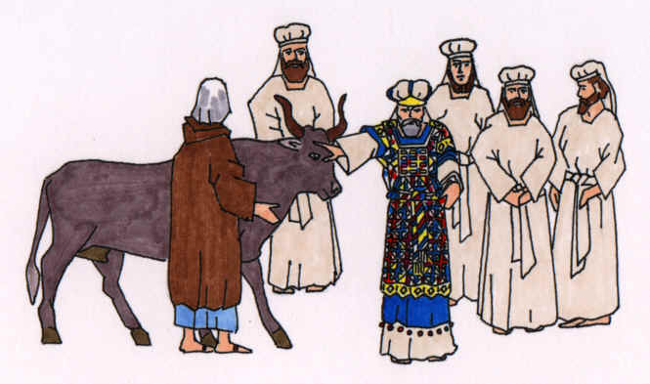
Priest laying his hands on the bull

Exodus 29:7 Then you will take אֶת־ oil, anointing and pouring it upon his head and anoint אֹתֹו him. 8 וְאֶת־ and you will bring his sons and put coats upon them. 9 And you will wrap אֹתָם them with girdles (sashes) Aaron and his sons and put the head pieces on them: and the priest’s office will be theirs for a permanent statute: and you will consecrate Aaron and his sons. 10 And you will bring אֶת־ a bullock before the Tabernacle of the Congregation: and you will put Aaron and his sons אֶת־ their hands upon the head of the bullock. C-MATS

Question: Why was the bull brought near to Aaron and his sons? It was brought to the priests for them to lean on it to confess sins and gain atonement. Chumash

Exodus 29:11 And you will kill אֶת־ the bullock before יהוה by the door of the Tabernacle of the Congregation. 12 And you will take the blood of the bullock and put it on the horns of the altar with your finger וְאֶת־ and all the blood pour at the bottom of the altar. C-MATS

Question: How was the blood placed on the Altar? Moses poured the blood in a basin and sprinkled the blood on the horns of the altar, so the blood would be visible on both sides. The only sacrifice requiring the blood to be applied with the finger is the sin offering. The other offerings required only that the blood be sprinkled on the horns. The priest ascended the ramp of the altar only for a sin offering, but he stood on the ground and sprinkled the blood for the other offerings. Chumash

Exodus 29:13 And you will take אֶת־ all the fat that covers אֶת־ the inner organs וְאֵת and the caul that is above the liver וְאֵת and the two kidneys וְאֶת־ and the fat and burn them upon the altar. 14 וְאֶת־ and the flesh of the bullock, וְאֶת־ and his skin וְאֶת־ and his dung you will burn with fire outside the camp: it is a חַטָּאת sin [offering]. 15 וְאֶת־ And also take one ram; and Aaron and will put his sons אֶת־ hands upon the head of the ram. 16 And you will kill אֶת־ the ram and you will take אֶת־ his blood and sprinkle it on all sides of the altar. 17 וְאֶת־ and the ram you will cut in pieces (quarters) and wash the inner organs (entrails) and his legs and put them with the pieces and his head. 18 And you will burn אֶת־ the whole ram upon the altar: it is a burnt offering to ליהוה: it is a sweet savor, an offering made by fire to ליהוה. C-MATS

Question: What made the aroma satisfying to יהוה? It is not the fragrance that matters. Rather, the aroma of the offering going up in smoke on the Altar gives satisfaction to יהוה, because it is testimony that He expressed His command and the nation carried it out. Obedience is the sweet aroma that יהוה wants. Chumash

Exodus 29:19 And you will take אֵת ram; the other and will put Aaron and his sons אֶת־ their hands on the head of the ram. 20 Then will you kill אֶת־ the ram and take his blood and put it upon the tip of the right ear of Aaron and upon the tip of the right ear of his sons and upon the thumb of their right hand and upon the great toe of their right foot and sprinkle אֶת־ the blood on all sides of the altar. C-MATS

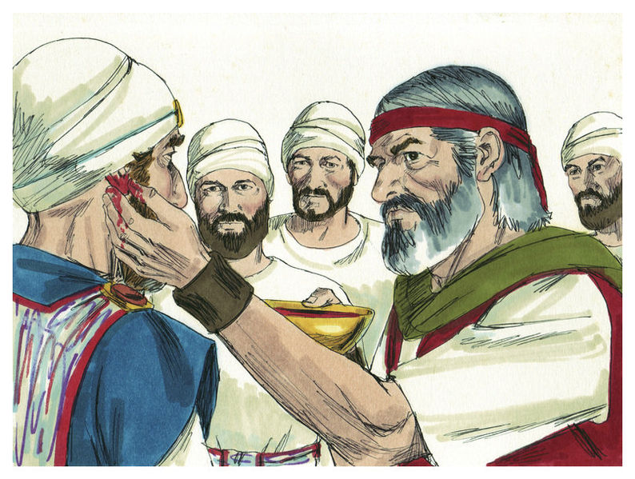
Moses puts the blood on the tip of the right ear of Aaron

Question: Why was the blood put on the thumb, ear, and toe?
The thumb represents our actions and our labor. All of us are called to minister to others.
The ear must be anointed to hear and rightly divide the Word of יהוה.
The toe speaks of movement. Our steps should be leading us along the path He has laid out for us.
Only the right ear, thumb, and toe are mentioned. The right-hand side is spoken of in the Bible as the side of strength and power since most people are right-handed.
Exodus 29:21 And you will take the blood that is on the altar and the anointing oil and sprinkle it upon Aaron and his son’s garments אִתֹּו with him: and Aaron and his sons will be consecrated אִתֹּו with him. 22 Also you will take the fat from the ram, the fat and the rump וְאֶת־ and the fat that covers אֶת־ the inwards (inner organs), וְאֵת and the caul above the liver, וְאֵת and two kidneys וְאֶת־ and the fat upon them וְאֵת and the right shoulder; for it is a ram of consecration: 23 And one loaf of bread, אַחַת one cake of oiled bread and אַחַת one wafer out of the basket of the unleavened bread that is before יהוה: 24 And you will put all in the hands of Aaron and his sons and they will wave אֹתָם them as a wave offering before יהוה. C-MATS

Question: What is the caul above the liver? The caul is the membrane which covers the upper part of the liver. Easton's Bible Dictionary

Question: How was the wave offering presented to יהוה? Both the priest and the owner of the sacrifice were engaged in the waving of the sacrifice before יהוה. The priest placed his hand under the owner’s hand and waved the sacrifice back and forth to the One to Whom the four directions of the world belong. Chumash

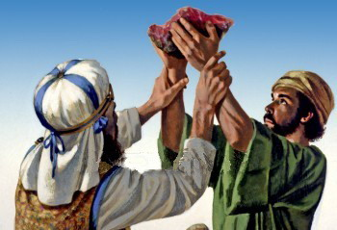
Wave offering

Exodus 29:25 And you will take אֹתָם them back from their hands and burn them upon the altar as a burnt offering, for a sweet aroma before יהוה: it is an offering made by fire to ליהוה. 26 And you will take אֶת־ the breast of the ram of Aaron’s ordination and wave אֹתֹו it (him) as a wave offering before יהוה: and it will be your part. C-MATS

Question: What was Moses’ portion of the offering? The breast is given to the one who performed the service for his portion. Since Moses officiated the rites, he received the breast and Aaron and his sons ate the rest. Chumash

Exodus 29:27 And you will sanctify אֵת the breast of the wave offering וְאֵת and the shoulder of the heave offering, which is waved and raised up, whether from the ram of the ordination, or anything else meant for Aaron and his sons: 28 And it shall be Aarons and his sons' by a statute for ever מֵאֵת from the children of Israel: for it is an heave offering: and it shall be an heave offering מֵאֵת from the children of Israel of the sacrifice of their peace offerings, even their heave offering to ליהוה. 29 And the dedicated garments of Aaron shall be his sons after him, to be anointed in it and to be confirmed (fulfilled) in them אֶת־ and to be consecrated. 30 And the son that is priest in his place will wear them for seven days, when he comes into the Tabernacle of the Congregation to minister in the sacred place. 31 וְאֵת and the ram you will take of the consecration and boil אֶת־ his flesh in the sacred place. 32 And will eat Aaron and his sons אֶת־ the flesh of the ram וְאֶת־ and the bread that is in the basket by the door of the Tabernacle of the Congregation. C-MATS

Question: Where were the sacrifices eaten? They were eaten in the courtyard of the Tabernacle, because they were most sacred sacrifices. Chumash

Exodus 29:33 And they will eat אֹתָם them with which the atonement was made to confirm אֶת־ to consecrate and to sanctify אֹתָם them: but a stranger will not eat it, because it is set apart (sacred). 34 And if any of the flesh or bread of the consecrations remain until morning, then you will burn אֶת־ the remainder with fire: it cannot be eaten, because it is sacred. 35 And you will do all these things which I have commanded you to Aaron and his sons: you will consecrate them for seven days. C-MATS

Question: How long did Moses operate as High Priest? Moses participated in bringing the offerings to יהוה for only 7 days, and then Aaron was the High Priest. Chumash

Exodus 29:36 And you will offer a bullock everyday for a חַטָּאת sin [offering] for atonement: וְחָטָאת and sin [offering] will be placed on the altar after you have made atonement and you will anoint אֹתֹו it (him) to sanctify it. 37 You will make atonement for the altar and sanctify אֹתֹו it (him) for seven days; and it will be a most sacred altar: whatever touches the altar will be sacred. 38 Now this is what you will offer upon the altar; two one-year old lambs everyday continually. 39 אֶת־ the lamb one you will offer in the morning; וְאֵת and lamb, the other, you will offer at evening. C-MATS
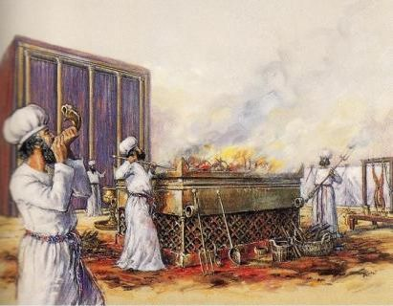
The morning offering
Question: How was the morning offering celebrated in the Temple? The offering of the sheep in the morning was a festive event in the Temple as the service proceeded, the Levites, accompanied by music, sang the song of the Day and when the service was over, everyone bowed, even the king, if He was present. Chumash

Exodus 29:40 And with one lamb bring a tenth deal (2 quarts) of flour mixed with a fourth part of a hin (1 quart) of oil from pressed olives; and a fourth part of a hin (1 quart) of wine for a drink offering. C-MATS

Question: What other offerings were always given with the animal? Meal (flour) and wine (libation) offering were given with the animal. The meal-offering was burned completely on the Altar and the wine libation was poured onto the Altar. The amounts of flour, oil, and wine varied according to the species of animal. Chumash

Exodus 29:41 וְאֵת and lamb, the other, you will offer at evening and you will do the same as the grain offering in the morning and the drink offering, for a sweet aroma, an offering made by fire to ליהוה. 42 This will be a continual burnt offering throughout all your generations at the door of the Tabernacle of the Congregation before יהוה: where I will meet with you to speak to you. 43 And there I will meet with the Children of Israel and the Tabernacle will be sanctified by My glory. 44 And I will sanctify אֶת־ Tabernacle of the Congregation וְאֶת־ and the altar: וְאֶת־ and both Aaron וְאֶת־ and his sons, I will sanctify to minister to Me in the priest’s office. 45 And I will live among the Children of Israel and will be their Elohim. 46 And they will know that I am יהוה their Elohim who brought אֹתָם them out of the land of Egypt, so that I may live among them: I am יהוה their Elohim. C-MATS

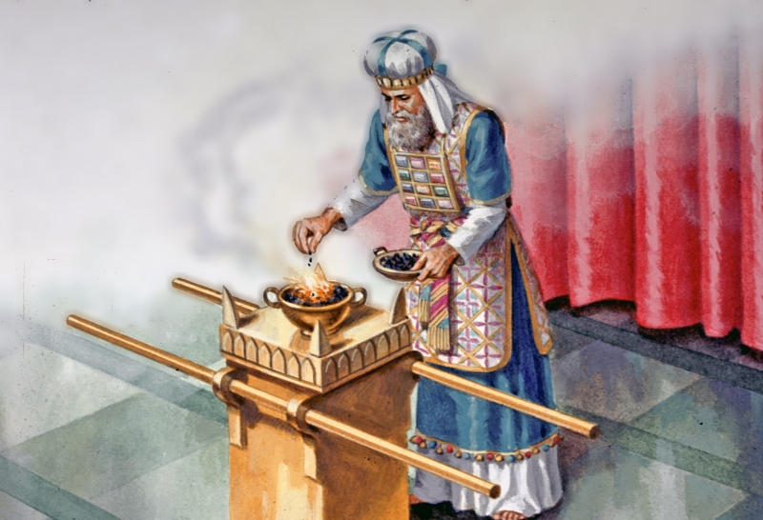
Altar of Incense

Exodus 30:1 And you will make an altar to burn incense upon: of acacia wood shall you will make אֹתֹו it (him). 2 It will be a cubit (18 inches) in length and width; it will be square: and two cubits (3 feet) high: the horns will be of one piece with it. 3 And you will overlay אֹתֹו it (him) with gold, pure, אֶת־ the top, וְאֶת־ and the sides וְאֶת־ and the horns; and you will make a crown molding of gold around the top of it. 4 And you will put two gold rings under the crown molding at the two corners on both sides; and they will be the places for the poles to carry אֹתֹו it (him). 5 And you will make אֶת־ the poles of acacia wood and overlay אֹתָם them with gold. 6 And you will put אֹתֹו it (him) before the veil that is by the Ark of the Testimony in front of the mercy seat that is over the testimony, where I will meet with you. 7 Aaron will burn on it sweet incense every morning: when he prepares אֶת־ the lamps, he will burn incense upon it. 8 And when lights Aaron אֶת־ the lamps at even (dusk) he will burn incense upon it, a perpetual incense before יהוה throughout your generations. C-MATS
Question: When is the incense burned in the Temple? It is burned every morning and at dusk-the time of day immediately following sunset. Chumash

Question: Why is the Altar of Incense not mentioned with the Menorah and the Table of Showbread? The Golden Altar’s function was entirely different from that of the Tabernacle as a whole. The Tabernacle structure brought יהוה’s glory to the nation and the sacrificial offerings created the “meeting place” of יהוה and Israel. Once the Tabernacle and its service brought His Presence to Israel, the incense was the prescribed means to welcome the King (יהוה) and show Him honor. Chumash

Exodus 30:9 You will not offer any strange incense, burnt sacrifice, grain offering or drink offering on it. C-MATS
Question: What is the difference between the offerings? A burnt offering is one of an animal or fowl. A grain offering is one of bread. A drink offering is one of wine. Chumash

Exodus 30:10 Aaron will make atonement upon its horns אַחַת once a year with the blood of the חַטַּאת sin [offering] of atonements: אַחַת once a year he will make atonement upon it throughout your generations: it is most sacred to ליהוה. C-MATS
Question: When is the sin offering made? It was made once a year on Yom Kippur. Chumash

Question: The priests had to dress a certain way to enter the Temple. What is the spiritual purpose of clothing? Clothing is a form of expression. The way we dress, or don't dress serves to tell others what we're about, and where our values lie. For instance, a spiritual person will tend to dress in a way that doesn't call attention to his body, so that others will relate to his inner essence, or soul. Clothing is much more than a 'fashion statement'; it is a powerful form of communication.

Question: Our body is the garment of the soul. What do you think this means? A garment, as elaborate as it may be, is when all is said and done, merely an outer covering for the person himself. The essence of a person is his soul, which lives forever and that his body is just a garment, or tool, which gives him the ability to exist and accomplish his spiritual tasks in the temporary physical world. We should appreciate and enjoy our garments, but we should never mistake them for being who we really are.
Spiritual Exercise: What kind of image do you create about yourself by the clothes you wear? Wear modest clothes and clean, pressed clothes and express the righteous person that you are this week.

Do You Know?

- ___ oil kept the light in the Menorah burning. (what kind of?)
- The lights of the Menorah burned ____. (when?)
- The priests wore linen ___ to cover their nakedness.
- What did the priests wear on their feet?
- The High Priest’s breastplate had ___ stones on it. (how many?)
- Each stone on the breastplate had the name of a ___ engraved on it.
- On the head plate on the High Priest’s turban was engraved “Consecrated to ___”,
- The High Priest’s robe was made of ____ wool. (what color?)
- The High Priest’s robe had ___ and ___ ___ on the hem.
- Two stones were on the shoulders of the High Priest with the names of the ___ engraved on them.
- The High Priest’s breastplate had ___ rows of stones with ___ stones in each row. (how many?)
- The ___ and ___ was kept in the High Priest’s breastplate to help make decisions.
- The priests sacrificed ___ lambs a day to יהוה- one in the morning and one at ____.
- The priests put flour, oil, and ___ on the daily sacrifices.
- Sweet smelling ___ was burned in the morning and at dusk.
- The priests refilled the oil in the ____ in the morning and at dusk.

Answers:
- olive
- continuously
- breeches (shorts)
- no shoes
- twelve
- tribe
- יהוה
- blue
- pomegranates, gold bells
- tribes
- 4,3
- Urim and Thummim
- 2, dusk
- wine
- incense
- Menorah

Haftorah

Question: Which temple is Ezekiel telling us about in chapter 43? The Israelites sinned against יהוה and the First Temple was destroyed by their enemies. The Shekinah glory was not in the second temple, but Ezekiel prophesies of a New Temple filled with His Presence that will be on earth during the reign of Yahusha. יהוה gives Ezekiel specific measurements for this New Temple just as Moses was given specific measurements for the First Temple.

Ezekiel 43:10 אַתָּה You Son of man, show אֶת־ House to אֶת־ the House of Israel, that they may be ashamed of their iniquities: and let them measure אֶת־ pattern. 11 And if they be ashamed of all that they have done, show them the form of the house and the fashion of it and the goings out of it and the comings in of it and all the forms of it and all the ordinances of it and all the forms of it וְאֵת and all its Torah: And show אֹותָם them and write it in their sight, that they may keep אֶת־ whole form of it וְאֶת־ and all the ordinances of it and do אֹותָם them. 12 זֹאת This is the Torah of the house; upon the top of the mountain the whole limit of it round about will be most Sacred. Behold, זֹאת this is the Torah of the house. 13 And these are the measures of the altar after בָּאַמֹּות in the cubits: The cubit is a cubit and a hand width; even the bottom will be a cubit and the width a cubit and the border of it by the edge of it round about will be a span: and this will be the higher place of the altar. 14 And from the bottom upon the ground even to the lower settle will be two אַמֹּות cubits and the width אֶחָת one cubit; and from the lesser settle even to the greater settle will be four אַמֹּות cubits and the width one cubit. 15 So the altar will be four אַמֹּות cubits; and from the altar and upward will be four horns. 16 And the altar will be twelve cubits long, twelve broad, square in the four squares of it. 17 And the settle will be fourteen cubits long and fourteen broad in the four squares of it; and the border about it will be half a cubit; and the bottom of it will be a cubit about; and his stairs will look toward the east. 18 And He said to me, Son of man, so said Adonai יהוה; These are the ordinances of the altar in the day when they will make it, to offer burnt offerings on it and to sprinkle blood on it. 19 And you will give to the priests the Levites that are of the seed of Zadok, which approach to Me, to minister to Me, said Adonai יהוה, A young bullock לְחַטָּאת for sin [offering]. 20 And you will take of the blood of it and put it on the four horns of it and on the four corners of the settle and upon the border round about: וְחַטַּאת and sin of אֹותֹו it (him) shall you cleanse and purge it. 21 You will take also אֵת bullock of הַחַטָּאת the sin [offering] and he will burn it in the appointed place of the house, outside the sanctuary. 22 And on the second day you will offer a kid of the goats without blemish לְחַטָּאת for sin [offering]; and they will cleanse אֶת־ the altar, as they did cleanse it with the bullock. 23 When you have made an end of cleansing it, you will offer a young bullock without blemish and a ram out of the flock without blemish. 24 And you will offer them before יהוה and the priests will cast salt upon them and they will offer אֹותָם them up for a burnt offering to ליהוה. 25 Seven days will you prepare every day a goat for a חַטָּאת sin offering: they will also prepare a young bullock and a ram out of the flock, without blemish. 26 Seven days will they purge אֶת־ the altar and purify אֹתֹו it (him); and they will consecrate themselves. 27 And when are expired אֶת־ these days, it will be, that upon the eighth day and so forward, will make the priests upon the altar אֶת־ your burnt offerings וְאֶת־ and your peace offerings; and I will accept אֶתְכֶם you, said Adonai יהוה. C-MATS

Brit Chadashah
Question: How are we supposed to be like the Menorah? Matthew 5:13 You are the salt of the earth: but if the salt have lost his savor, wherewith shall it be salted? It is good for nothing, but to be cast out, and to be trodden under foot of men. 14 You are the light of the world. A city that is set on a hill cannot be hid. 15 Neither do men light a candle and put it under a bowl, but it is placed on a candlestick, which gives light to all that are in the house. 16 Let your light so shine before men, that they may see your good works, and glorify your Father which is in heaven. 17 Think not that I am come to destroy the Torah, or the prophets: I am not come to destroy, but to fulfill. 18 For verily I say unto you, Till heaven and earth pass, one jot or one tittle shall in no wise pass from the Torah, till all be fulfilled. 19 Whosoever therefore shall break one of these least commandments, and shall teach men so, he shall be called the least in the kingdom of heaven: but whosoever shall do and teach them, the same shall be called great in the kingdom of heaven. 20 For I say unto you, That except your righteousness shall exceed the righteousness of the scribes and Pharisees, you shall in no case enter into the kingdom of heaven. C-MATS

Question: The Temple is no longer with us, but יהוה still is pleased with a sacrifice from us. How can we make a sacrifice to יהוה today? Giving through love is pleasing to Elohim. Philippians 4:10 But I rejoiced in יהוה greatly, that now at the last your care of me has flourished again; wherein you were also careful, but you lacked opportunity. 11 Not that I speak in respect of want: for I have learned, in whatsoever state I am, therewith to be content. 12 I know both how to be abased, and I know how to abound: everywhere and in all things I am instructed both to be full and to be hungry, both to abound and to suffer need. 13 I can do all things through Mashiach which strengthens me. 14 Notwithstanding you have well done, that you did communicate with my affliction. 15 Now you Philippians know also, that in the beginning of the gospel, when I departed from Macedonia, no assembly communicated with me as concerning giving and receiving, but you only. 16 For even in Thessalonica you sent once and again unto my necessity. 17 Not because I desire a gift: but I desire fruit that may abound to your account. 18 But I have all, and abound: I am full, having received of Epaphroditus the things which were sent from you, an odor of a sweet smell, a sacrifice acceptable, well pleasing to Elohim. 19 But my Elohim shall supply all your need according to his riches in glory by Mashiach Yahusha. 20 Now to Elohim and our Father be glory forever and ever. Amen. C-MATS
A LUCKY BREAK

The van would be turning into the hospital parking lot any minute and I had absolutely no idea what I was going to say. When the school social worker first came around looking for volunteers to go visit the sick kids in the local children's hospital I figured I'm a pretty upbeat kind of guy and if I could spend an hour and cheer up one of these poor kids who were stuck in the hospital, why not? But as we got closer, I got more and more nervous. After all, any kid who was so sick he had to be cooped up long term in a hospital ward was bound to be really down and depressed, how could I possibly say anything that would make him feel better?
I and the other volunteers got out of the van, and they told each of us which patient to visit. Mine was a kid named Jonnie Green in room 706. It said on the paper that he had been in a bad car accident and had already been in the hospital for more than three months! Boy, he must be down.
I only hoped I wouldn't make him feel any worse. I nervously approached the room, but when I got there, I breathed a sigh of relief. It seemed like the patient wasn't there. There was just some kid sitting there, about my age wearing a sports T-shirt and a baseball cap, laughing out loud as he read a comic book. Must be the guy's brother or another volunteer, I figured.
I walked in. "Um, I'm looking for Jonnie Green. Are you also here to visit him?"
The kid turned to me with one of the brightest smiles I ever saw. "Yeah," he said with a laugh, "but I get to visit him every day and nights too!"
Huh? I walked closer and started getting confused. Why was this visitor sitting in a wheelchair? "Oh, wait a minute, are you…I mean…"
He stuck out his hand, with an I.V. tube sticking out of it, "Jonnie Green, in the flesh. And who do I have the pleasure to be meeting?"
I introduced myself and we began to talk. I had prepared a whole ‘cheer-up' speech to say, but I never got around to it. It seemed Jonnie was also a Saints fan, and once we got talking football and all sorts of other regular stuff, I would have almost forgot that I was in a hospital room if a nurse or doctor didn't come in every once in a while to give Jonnie a pill or check his blood pressure.
"Lunch time Jonnie!" announced a tall nurse as she wheeled in a tray of steaming food. "Should I help you?"
"Thanks Sheila," he said with his thousand-watt smile, "but I think I'll be okay, I have a friend here today."
He looked at me and smiled. "Um, Gary, do you think you could give me a hand getting to that sink over there?"
"Sure, tell me what to do."
He handed me his crutches and I held him up by the arm as he slowly made his way across the room. I could hear him groaning in pain with each step, yet the smile never left his face.
"Jonnie," I said as we walked, "How do you do it? How are you able to keep yourself ‘up' and smiling in spite of everything you went through, and are still going through?"
He gave me a funny look, as he bent to wash his hands. "You got it all wrong, Gary. I'm like this because of everything I went through."
He must have seen the shock on my face, "Please just help me get back over to the wheelchair and I'll explain."
"Before the accident I was just a regular kid and not a very cheerful one either. In fact you could say I was pretty down on life. Then one day we were just out on a family trip and the next thing I knew I woke up in this hospital. I had broken a lot of bones and first I could barely move, or even talk, and the doctors didn't know if I ever would, either. Um, could you please help me lift up the drink, if I do it alone I'll end up wearing it," he laughed.
"Like most people, I had been moving my hand without thinking about it all my life and it was no big deal, right? But you know, the first time I was able to move my hand after the accident I felt a high like I had won an Olympic gold medal. I realized what an amazing gift it was to be able to move your hand, or even have one. It's still not 100%, but you should have seen me a couple of months ago."
I helped him lift the cup and felt my hand start to tingle as Jonnie continued. "Then I started seeing other things different too.”I used to complain if my mom didn't make exactly the food I liked, but then I discovered what a gift it was to be able to eat anything. You know at first I could only drink a little water, and had to ‘eat' everything through this tube in my arm! Now as you can see, I'm up to soup and ice-cream!"
"Doing okay Jonnie?" asked the nurse, popping in head. "Great!" he smiled, "I have excellent help." I blushed as he went on. "I had always been kind of grumpy and a loner at home, but here all the nurses I needed to help me with every little thing made me realize what a gift it was to have other people around who were willing to help." I gulped as I remembered the not-so-nice parting comment I had made to the hard-working serving lady about the lunch in school that day.
"I'm not telling you it's been easy, Gary—it hasn't, but in a way this accident has been the best thing that could have happened to me. One thing I do know, at least as far as my attitude goes, I'm way healthier now than before I got here."
‘ALL VISITING STUDENTS PLEASE RETURN TO THE MAIN LOBBY' came the announcement crackling over the intercom. The time had flown, and as I looked into this amazing kid's glowing face, I could see that he meant every word he said. We shook hands and made plans to see each other again.
I got back out to the van and the social worker turned to me, "Hey Gary, how did the cheer-up visit go?"
"Great, the kid really cheered me up a lot." I smiled. I thought he would be surprised, but he looked like he understood exactly what I meant.

Question: How did Gary feel when he first went to visit the kid in the hospital? He felt like he had to cheer up the kid who was going to be really sad because of what happened to him.

Question: How did he feel after meeting Jonnie? He saw how happy Jonnie was and saw how difficulties can help a person grow.

Question: What did Gary learn from the time he spent with Jonnie? He had assumed that since Jonnie was laid up in the hospital he was going to be cranky and miserable. But when he got there and saw how up the kid was, he couldn't believe it. But his biggest surprise came when Jonnie told him how it was the very experience of the accident and all the hard times that came with it which gave him a new and brighter outlook on life that made him feel more up than he ever had before.

Question: Why do you think Jonnie appreciated things like walking and eating, after his accident more than before it? We all have many wonderful gifts from יהוה, starting with life itself on down. But human nature is to fall into the trap of just taking these for granted. Jonnie's experience of almost losing these gifts was a wake-up call that helped him to really see, and appreciate all the gifts he really had.
Question: Why do difficulties build a person up? Just like a person's body gets stronger through working hard and doing exercise, so does his character. An easy life, as pleasant as it may be, has the side effect of leaving one's character a little weak and flabby. We needn't seek out difficulties, nor do what we can to avoid them, but if and when they do come, we should know that we are getting a soul work-out, and if we handle them right, we will come out the other end both stronger and happier people.

Question: What does it take to succeed? It doesn't take big leaps or dramatic acts to succeed, only continual and consistent effort. This week's Torah portion describes the continually lit lamp, the Menorah, and the continual offering - the Altar of Incense in the Tabernacle. Both were distinguished by their quality of consistency. We can take a lesson from them and realize that the surefire way to reach our goals is through consistent work.

"OUT OF THE WOODS"

"Great job, Michael. We're proud of you!" My uncle Jack was all smiles as he pumped my hand. I had just finished my part in the school play, and everyone seemed so happy about how well I did. I smiled back, and winked over at my friend, Steve, who was standing across the room. I wonder if, besides him, any of them realized just how close I came to giving up and not doing it at all.

You see, I have a lot of talents. I can run faster than anyone else in my class, and nobody can beat me at chess. But when it comes to things like reading in front of others, let's just say I'm not at the top of the class. The words and letters just seem to jumble and get lost somewhere between my eyes and my tongue. So I would go twice a week to Mr. Cook's house for extra tutoring to help me become a better reader. He was a nice enough guy, and his wife always served really good homemade cakes and cookies. But I felt like I was getting nowhere, fast, and after a couple of reading lessons I was ready to throw in the towel.

Since Mr. Cook lived on the other side of the neighborhood, the fastest way to get there was to cut through the path in the woods behind my house. A lot of times my buddy, Steve, who lived next door to the tutor, would meet me after the lesson and we would either spend the afternoon hanging out at his place, or we'd walk through the woods together to mine. That's what we were doing that day, but I wasn't very good company. That week I had really stumbled through the part for my school play, and as we hiked along the well-worn path, all I could do was fuss and complain.
"That's it, I'm quitting. Lessons or no lessons, I just can't read this part, and I never will."
Steve tried to get me to laugh it off, but then he saw I was serious. "But you only started reading lessons a few weeks ago, what do you expect?” he asked.
"A few weeks, few months, few years ... what difference does it make? With my thick head I'll never get it, so what's the point of practicing? Whenever I try to read, the words come out more tangled up than those thorn bushes over there!" I said bitterly, pointing to the side of the path.
We walked a bit more in silence, then Steve turned to me with a funny look. "Mike, I think I have your answer." I didn't know I had asked him a question. "The only way to get through the thorn bushes is to make a path."
He seemed excited about his idea, but I had no idea what he was talking about. "What?"
"Don't you get it? If the woods are so full of brambles and thorn bushes, how come we can walk across it so easily?"
I glared at him. My mind was burned out enough from the lesson; what did I need to play 20 questions for? "What kind of question is that? We don't walk through the bushes, we walk down the path."
"Ah hah!" he said, "And how did the path get here? Did it just appear out of thin air?"
I picked up a rock and lobbed it into a nearby stream. I wasn't sure what he was driving at, but it was actually an interesting question. I thought back about when the two of us first became friends. There really wasn't any path back then. I remembered how hard it was to walk through, and how Steve and I had kept cutting through the same way to get to each other's houses. After a while all that walking, day after day, sort of pushed aside and crushed down a few of the bushes, and smoothed out a path...

I think I was starting to get Steve's point. "You're trying to say that by cutting through the same place over and over, we made the path through the thorn bushes, right?"
"That's right. Even though each time we walked through it didn't seem to change anything, eventually it added up and we had a path. Same thing here - if you stick to lessons and keep going over them every day, I'm sure you'll..."
"I'll cut through the thorn bushes in my head and start to read better, right?"
"That's right!"

We played a little less that day since I had to practice for the school play. And while it wasn't easy - I had some pretty tough thorns in my head - little by little, I started to read much better, and by the time my school play rolled around, I was ready. It was a great day and everyone was proud. But no one was happier than me, and my friend, who taught me how by sticking to it, I could get unstuck.

Question: What was the lesson Michael learned from the path in the woods? The path didn't form overnight. Only little by little, after the boys walked through the same place in the woods many times, did the tough thorns and brambles smooth out into a path. Michael came to see from here how a consistent, repeated effort can over time clear a path through life's obstacles, like his reading challenges.

Question: In your opinion, which is a more important ingredient for success: effort or ability? Certainly having a talent or ability at something is a big advantage, but it isn't enough to succeed. Far more important is the willingness to diligently keep working at something, even if at first we don't seem to be getting anywhere. Eventually our efforts will pay off; not only can we put our talents to maximum use, but we can even develop and bring out abilities in us that we never knew we had.

Question: Would יהוה be doing us a bigger favor if he let us succeed without really trying? We might achieve a measure of immediate gratification, but the pleasure would soon fade. The ultimate pleasure consists not only in obtaining a desired result, but in the accompanying satisfaction of knowing that we have truly 'earned' it by having put in our utmost effort to get there.

Question: Is all the pain worth the gain? It depends on what we are aiming for. If our idea of a good life is just to coast through it as smoothly as we can, it's hard to see the benefit of hard times. But if we begin to see life in a spiritual and righteous framework and focus on the everlasting value of wisdom and character growth, the growth we gain from hard times will seem worth the price and maybe even a bargain.

Question: If someone maintains that he tried but didn't succeed, or conversely succeeded without trying, we shouldn't believe him. How do you understand this statement? True success is defined as reaching one's full potential. This can only come about through sincere and consistent effort. Therefore, only one who fully applies himself in a given area can be considered a genuine success in that area. One who doesn't, no matter how much he accomplishes, has in a sense failed, as he could have accomplished so much more.

Question: The special inauguration ceremony that the people made when they first started to use the Holy Tabernacle made sure things got off to a good start. When it comes to doing something worthwhile, ‘all beginnings are difficult.' What do you think this means? To begin something means that we have to overcome our initial inertia and leave our comfort zone, which is never easy to do. However, if we persevere, we'll gain one of the greatest pleasures there is—the pleasure of accomplishment.


Question: Is there anything we can do in situations when things get off on the 'wrong foot?' We never have to feel stuck in a pattern due to some unfortunate earlier choice, with willingness and a little extra effort; we can always 'begin again.'



Resources:
The Stone Edition of The Chumash
The Complete Messianic Aleph Tav Scriptures C-MATS www.AlephTavScriptures.com
“Weekly Torah Portion” from www.aish.com

