VAYELECH (and he went)

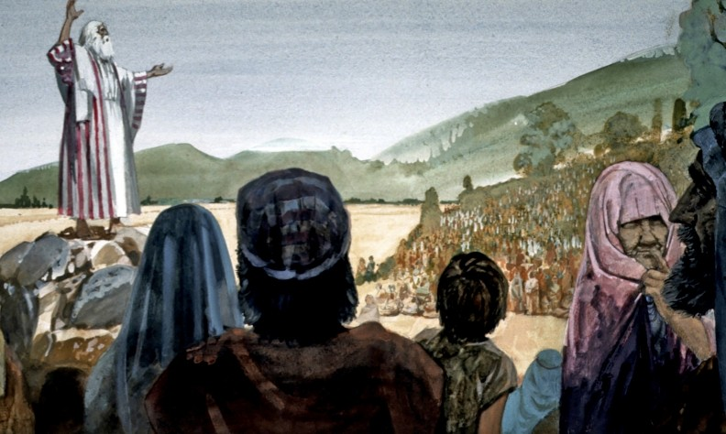

Vayelech recounts the events of Moses’ last day of earthly life. He transfers the leadership to Joshua, and concludes writing the Torah in a scroll which he entrusts to the Levites for safekeeping in the Ark of the Covenant. Vayelech concludes with the prediction that the people of Israel will turn away from their covenant with יהוה, causing Him to hide His face from them, but also with the promise that the words of the Torah would not be forgotten by their descendants.

Deuteronomy 31:1 And Moses went and spoke אֶת־ these words to all Israel. 2 And he said to them, I am 120 years old this day; I cannot go out and come in anymore: and ויהוה said to me, You will not cross over אֶת־ the Jordan this day. C-MATS
Question: Why did Moses say “I am 120 years old this day”? Today my days and years were fulfilled; on this day I was born (Moses’ birthday), and on this day I shall die... This is to teach us that יהוה fulfills the years of the righteous to the day and to the month, as it is written (Exodus 23:26): "אֶת־ the number of your days I will fulfill (You will live out the full span of your lives)." Chumash
Question: What does it mean by “I cannot go out and come in anymore”? Did this mean physically he was too old to go into the Promised Land? Scripture states regarding Moses, “And Moses was 120 years old when he died: his eyes were undimmed and his vigor undiminished.” (Deuteronomy 34:7), which teaches us that his powers were intact even on the day of his passing. So what then is the meaning of “I cannot go out”? Here it means: “I am not permitted,” because authority was taken from him and granted to Joshua. Chumash
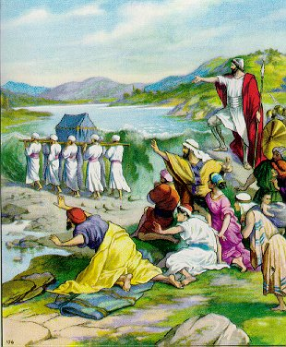
Joshua crosses the Jordan

Deuteronomy 31:3 יהוה your Elohim will cross over before you and He will destroy אֶת־ these nations from before you and you will possess them: and Y'hoshua (Joshua) will cross over before you as יהוה said. 4 And יהוה will do to them as He did to Sihon and to Og, kings of the Amorites and unto the land of אֹתָם them, whom He destroyed. 5 And יהוה will defeat them ahead of you, so that you may do to them according to all the commandments which I have commanded אֶתְכֶם you. C-MATS
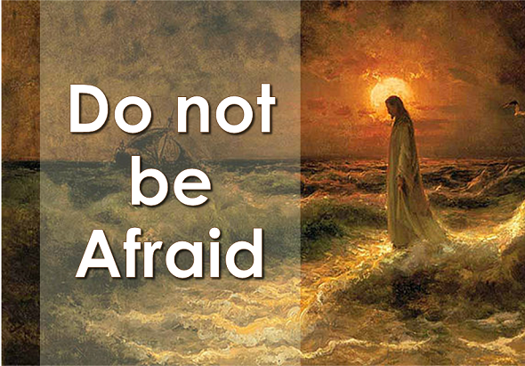
Do not be afraid
Deuteronomy 31:6 Be strong and be bold, do not fear, or be afraid of them: because יהוה your Elohim goes with you; He will not fail you or forsake you. 7 And Moses called to Y'hoshua and said to him in the sight of all Israel, Be strong and be bold: because אַתָּה you must go with אֶת־ people to the land which יהוה has sworn to their fathers to give them וְאַתָּה and you will cause אֹותָם them to inherit it. C-MATS
Question: What commandment did Moses give Joshua? Does this commandment apply to us today? Moses called Joshua and said to him in the presence of all Israel, "Be strong and be bold, do not fear." We too must be strong and courageous and overcome all temptations to sin. We must not fear men but trust יהוה in all things.
Deuteronomy 31:8 And ויהוה goes before you; He will be with you, He will not fail you, neither will He forsake you: do not fear or be dismayed. 9 And wrote Moses הַזֹּאת this אֶת־ Torah and delivered it to the priests, the sons of Levi, who bore אֶת־ Ark of the Covenant of יהוה and to all the elders of Israel. C-MATS
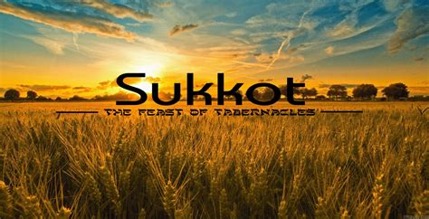

Deuteronomy 31:10 And Moses commanded אֹותָם them saying, At the end of every seven years according to the year of release during the Feast of Tabernacles, 11 When all Israel comes to appear אֶת־ before יהוה your Elohim in the place which He will choose, you will read הַזֹּאת this אֶת־ Torah, that day before all Israel so they can hear it. C-MATS
Question: Who reads the Torah to the people at the end of every seven years? The king reads to the entire nation from Deuteronomy. While reading the book of Deuteronomy to the people every seven years at the Feast of Tabernacles, the king would sit upon a wooden platform that was erected in the courtyard of the Temple and the entire nation would come together and listen to the king read to them. The reason for this commandment is that the primary foundation of Israelites life is the Torah, and through it Israelites are distinguished from all other nations to enjoy the highest possible spiritual pleasure. This being so, it is fitting that all Israel -- men, women, and children -- should come together to hear it read as a national affirmation that the Torah is our foundation, majesty, and splendor (Rambam, Hil. Chagigah 3:3; Chinuch 612). Chumash
Deuteronomy 31:12 Gather together אֶת־ the people, the men and women and children and your stranger who lives within your towns, that they may hear and that they may learn and fear אֶת־ יהוה your Elohim and observe and do אֶת־ all the words of הַזֹּאת this Torah. C-MATS

Jordan River

Deuteronomy 31:13 And their children, who have not known these laws, may hear and learn to fear אֶת־ יהוה your Elohim as long as אַתֶּם you live in the land when אַתֶּם you cross over אֶת־ the Jordan to possess it. 14 And יהוה said to Moses, See, your day has come that you must die: Call אֶת־ Y'hoshua and present yourselves in the Tabernacle of the Congregation, that I may give him a charge. And Moses and Y'hoshua went and presented themselves in the Tabernacle of the Congregation. C-MATS
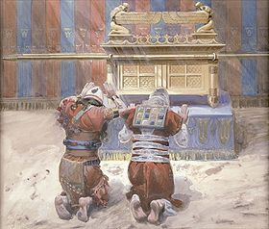
Joshua and Moses before יהוה
Deuteronomy 31:15 And יהוה appeared in the Tabernacle in the pillar of a cloud: and the pillar of the cloud stood over the door of the Tabernacle. 16 And יהוה said to Moses, You will sleep with your fathers and this people will rise up and go whoring after the gods of the strangers of the land where they are going and will forsake Me and break אֶת־ My covenant, which I have made אִתֹּו with them. 17 Then My anger will be aroused against them in that day and I will forsake them and I will hide My face from them and they will be devoured and many evils and troubles will befall them; so that they will say in that day. Haven’t these evils come upon us, because our Elohim is not among us? 18 And I will certainly hide My face in that day because of all the evils they have done by turning to other gods. C-MATS
Question: What does יהוה mean by “I will certainly hide My face in that day”? There are times when יהוה hides His face. But then there are times when יהוה hides His face and we don't even realize that His face is hidden; we dwell in darkness, and think it is light. Chumash
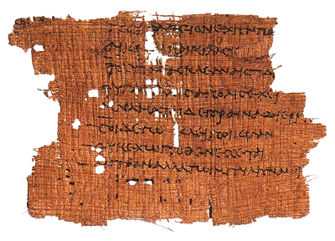
Teach the Israelites this song.

Deuteronomy 31:19 Now therefore, write for you הַזֹּאת this אֶת־ song and teach it to אֶת־ Children of Israel and have them learn it, so that הַזֹּאת this song may be a witness for Me against the Children of Israel. C-MATS
Question: Why is the next Torah section called a song? Haazinu is called a song because Israelites always chant it and it is written in the form of poetic verse (Ramban). It was written as a song, so they could sing it to their children. Chumash
Deuteronomy 31:20 For when I have brought them into the land, which I swore to their fathers that flows with milk and honey; and they have eaten and filled themselves and grown fat; then they will turn to other gods and serve them and provoke Me and break אֶת־ My covenant. C-MATS
Question: Why did the Israelites turn to other gods in times of abundance? Should this be a warning for us? They will eat and be satisfied, and live on the fat of the land-have abundance. We should seek יהוה with all our heart even in times of abundance to insure that we never turn away from Him. Chumash
Deuteronomy 31:21 הַזֹּאת This song will testify against them as a witness after many evils and troubles have come upon אֹתֹו them (him); because it will still be recited by their descendants and they will not have forgotten it: because I know אֶת־ their imagination even now before I brought them into the land which I swore. C-MATS
Question: What promise does יהוה give to His people? Despite the starkness of the prophecy that Israel will slide into sin and make יהוה angry, there is this comforting promise that the Torah will never be completely forgotten (Rashi). History shows over and over again that there was a revival of Torah study after times when it seemed as if its decline was irreversible. Chumash

Deuteronomy 31:22 Therefore, wrote Moses הַזֹּאת this אֶת־ song on the same day and taught it to אֶת־ Children of Israel. 23 And He commissioned אֶת־ Y'hoshua the son of Nun and said, Be strong and be bold: because אַתָּה you will bring אֶת־ Children of Israel into the land which I swore to them: and I will be with you. C-MATS

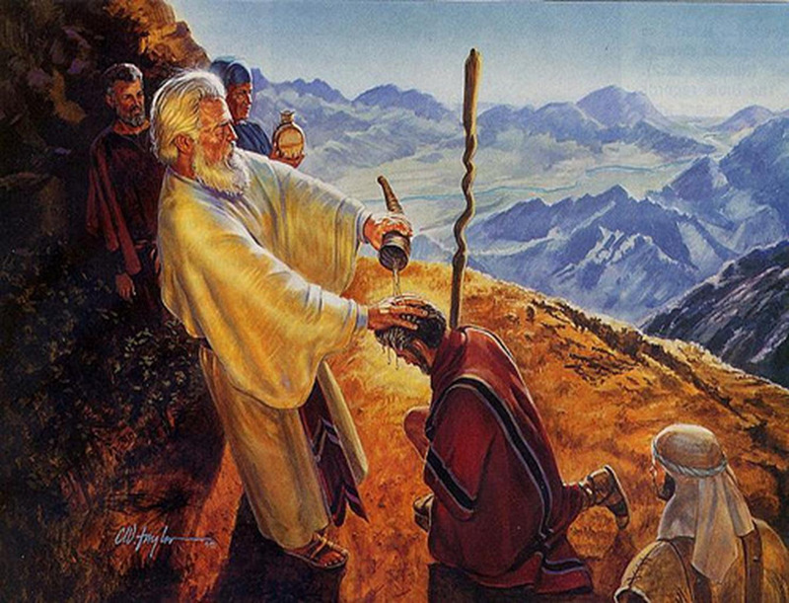
Moses anoints Joshua as leader of Israel

Deuteronomy 31:24 After Moses finished writing אֶת־ the words of הַזֹּאת this Torah in a book, 25 That commanded Moses אֶת־ the Levites, who carried the Ark of the Covenant of יהוה, saying, 26 Take אֵת this Book of the Torah and put אֹתֹו it (him) next to the Ark of the Covenant of יהוה your Elohim that it may be there for a witness against you. 27 For I know אֶת־ your rebellion וְאֶת־ and your stiff neck: even while I am still alive with you today you have been rebellious against יהוה; and how much more will you do so after my death? 28 Gather to me אֶת־ all the elders of your tribes and your officers that I may speak to them in their ears אֵת words and call to witness against them אֶת־ the heaven וְאֶת־ and the earth. 29 Because I know that after my death you will utterly corrupt yourselves and turn aside from the way which I have commanded אֶתְכֶם you; and evil will come upon אֶתְכֶם you in the latter days because you will do אֶת־ evil in the sight of יהוה to provoke Him to anger through the things that you do. 30 And Moses spoke to all the congregation of Israel אֶת־ words of הַזֹּאת this song. C-MATS
Question: Why did Moses say that after his death the Israelites will corrupt themselves? Although Moses predicted that the national corruption would begin as soon as he died, Scripture testifies that Israel remained righteous for as long as Joshua lived (Judges 2:7 And served the people אֶת־ יהוה all the days of Y'hoshua and all the days of the elders that outlived Y'hoshua, who had seen אֶת־ all the great work of יהוה that he had brought for Israel.). This shows that a teacher loves his student like himself, so that Moses felt that he was still alive as long as Joshua lived (Rashi). Chumash
Question: How did the Israelites feel about Moses no longer being their leader? The Israelites had to face a big change when Moses, their great teacher and leader, gathered them together to tell them he would be leaving this world very soon. He wanted to share his wisdom with them one last time. Although the people felt sad and anxious that he was leaving, Moses tried to encourage them and to help them to realize that their time together had been valuable and what they had gained from the opportunity would remain with them. We can learn from this how to deal positively with life's transitions and know that even if something good comes to an end, the good that we found in it will remain with us forever.
Question: Is it okay to feel sad when good things come to an end? It's very normal. We wish that good things could last forever. But it's also important to remember that the memories and lessons of those times will always stay with us, and that יהוה puts each person or experience in our life for just the right amount of time and for our best.
Question: What is so hard about facing changes, and what can we do to make transitions easier? People like a sense of security, to feel that things are the same as always. Facing changes, even if the changes themselves aren't unpleasant, shakes us out of our familiar routine and can cause us to feel less secure. One way to deal with these feelings is to develop and emphasize the parts of ourselves that will always be with us, such as our values, the spiritual side of ourselves, and our closeness to יהוה, Who never changes. When we do this, we have a steady, unchanging basis to our lives that give us the power to deal securely with whatever changes do come our way.

Question: Do you believe that people have within them the ability to handle any change that life may bring them? Of the many changes and transitions a person will encounter in life, many will be pleasant, others less so. The one thing that these transitions have in common is that they are all specifically sent to us by יהוה as a chance to learn and grow spiritually. יהוה will never send us a situation that is beyond our ability to handle. This makes sense when we realize that any challenges were sent specifically to us for a specific purpose. We definitely have the tools within us to handle whatever comes our way. It's only up to us to make use of these tools.
Spiritual Exercise: Examine a difficult change in your life and see all the good that has come from it. How have you grown spiritually from this change?
Haftorah
The prophet Hosea exhorts the Israelites to return to יהוה your Elohim encouraging them to repent sincerely and ask for יהוה's forgiveness. Hosea urges the Israelites to put their trust in יהוה, not in Assyria, powerful horses or idols. At that point, יהוה promises to remove His anger from Israel. The prophet then goes on to foretell the return of the exiles and the end of idol-worship amongst the people.

Hosea 14:1 O Israel, return to יהוה your Elohim; for you have fallen by your iniquity. 2 Take with you words and turn to יהוה: say to Him, take away all iniquity and receive us graciously: so will we render the calves of our lips. 3 Asshur will not save us; we will not ride upon horses: neither will we say anymore to the work of our hands, You are our gods: for in you the fatherless finds mercy. 4 I will heal their backsliding, I will love them freely: for My anger is turned away from him. 5 I will be as the dew to Israel: he will grow as the lily and cast forth his roots as Lebanon. 6 His branches will spread and his beauty will be as the olive tree and his smell as Lebanon. 7 They that live under his shadow will return; they will revive as the corn and grow as the vine: the scent of it will be as the wine of Lebanon. 8 Ephraim will say, what have I to do anymore with idols? I have heard him and observed him: I am like a green fir-tree. From Me is your fruit found. 9 Who is wise and he will understand these things? Prudent and he will know them? For the ways of יהוה are right and the just will walk in them: but the transgressors will fall in it. C-MATS

Micah describes יהוה's kindness in forgiving the sins of His people. Micah concludes with an entreaty to יהוה to remember the pacts He made with the Patriarchs, Abraham, Isaac and Jacob.

Micah 7:18 Who is an Elohim like you that pardons iniquity and passes over the transgression of the remnant of His heritage? He retains not His anger forever, because He delights in loving-kindness. 19 He will again have compassion upon us; He will tread our iniquities under foot; and you will cast all our sins into the depths of the sea. 20 You will perform the אֱמֶת truth to Jacob and the loving-kindness to Abraham, which you have sworn to our fathers from the days of old.
C-MATS

Joel describes an entire congregation–old and young, men and women–coming together to purify themselves and get closer to יהוה. This imagery reminds us of the task that awaits us on Yom Kippur.

Joel 2:15 Blow the trumpet in Zion, sanctify a fast, call a solemn assembly; 16 Gather the people, sanctify the assembly, assemble the old men, gather the children and those that suck the breasts; let the bridegroom go forth from his chamber and the bride out of her closet. 17 Let the priests, the ministers of יהוה, weep between the porch and the altar and let them say, spare your people, O יהוה and give not your heritage to reproach, that the nations should rule over them: why should they say among the peoples, where is their Elohim? 18 Then was יהוה jealous for His land and had pity on His people. 19 And יהוה answered and said to His people, Surely, I will send you אֶת־ grain and new wine and oil and you shall be satisfied with אֹתֹו it (him) and אֶתֵּן I will make אִתְּכֶם you no more a reproach among the nations; 20 וְאֶת־ and the northern army I will remove far off from you and will drive him into a land barren and desolate, with אֶת־ his face toward the eastern sea and his hinder part into the western sea; and his stench shall come up and his ill savor shall come up, because he has done monstrous things. 21 Fear not, O land, be glad and rejoice; for יהוה has done great things.
Joel 2:22 Be not afraid, you beasts of the field; for the נְאֹות pastures of the wilderness do spring, for the tree bears its fruit, the fig-tree and the vine do yield their strength. 23 Be glad then, you children of Zion and rejoice in ביהוה your Elohim; for He gives you אֶת־ the former rain in just measure and He causes to come down for you the rain, the former rain and the latter rain, in the first month. 24 And the floors shall be full of wheat and the vats shall overflow with new wine and oil. 25 And I will restore to you אֶת־ the years that the locust has eaten, the canker-worm and the caterpillar and the palmer-worm, My great army which I sent among you. 26 And you shall eat in plenty and be satisfied and shall praise אֶת־ name of יהוה your Elohim that has dealt wondrously with you; and My people shall never be put to shame. 27 And you shall know that I am in the midst of Israel and that I am יהוה your Elohim and there is none else; and My people shall never be put to shame. C-MATS

Brit Chadashah
Paul would not have known the sinfulness of his thoughts, motives, and actions, but by the law. That perfect standard showed how wrong his heart and life were, proving his sins to be more numerous than he had before thought, but it did not contain any provision of mercy or grace for his relief. Not the law, but sin discovered by the law, was made death to the apostle. Henry
Romans 7:7 What shall we say then? Is the Torah sin? Elohim forbid. Nay, I had not known sin, but by the Torah: for I had not known lust, except the Torah had said, You shall not covet. 8 But sin, taking occasion by the commandment, wrought in me all manner of concupiscence. For without the Torah sin was dead. 9 For I was alive without the Torah once: but when the commandment came, sin revived, and I died. 10 And the commandment, which was ordained to life, I found to be unto death. 11 For sin, taking occasion by the commandment, deceived me, and by it slew me. 12 Wherefore the Torah is holy, and the commandment holy, and just, and good. C-MATS

Believers have reason to be contented with their present lot in life. The true believer shall have the gracious presence of יהוה with him, in life, at death, and forever. Men can do nothing against יהוה, and יהוה can make all that men do against his people, to turn to their good. Henry
Hebrews 13:5 Let your conversation be without covetousness; and be content with such things as you have: for he has said, I will never leave you, nor forsake you. 6 So that we may boldly say, Adonai is my helper, and I will not fear what man shall do unto me. 7 Remember them which have the rule over you, who have spoken unto you the word of Elohim: whose faith follow, considering the end of their conversation. 8 Yahusha haMashiach the same yesterday, and today, and forever. C-MATS
WHAT HAPPENS NEXT?
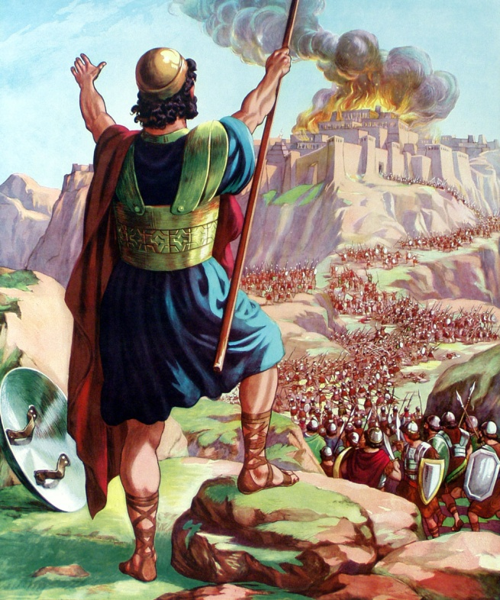
Story of Joshua
Y'hoshua 3:1 And Y'hoshua rose up early in the morning; and they removed from Shittim and came to the Jordan, he and all the Children of Israel; and they lodged there before they passed over. 2 And it came to pass after three days, that the officers went through the midst of the camp; 3 And they commanded אֶת־ the people, saying, When you see אֵת the Ark of the Covenant of יהוה your Elohim and the priests with the Levites bearing אֹתֹו it (him), וְאַתֶּם and you shall remove from your place and go after it. 4 Yet there shall be a space between you and it, about two thousand cubits by measure: come not near to it that you may know אֶת־ the way by which you must go; for you have not passed this way before. 5 And Y'hoshua said to the people sanctify yourselves; for tomorrow יהוה will do wonders among you. 6 And Y'hoshua spoke to the priests, saying, Take up אֶת־ the Ark of the Covenant and pass over before the people. And they took up אֶת־ the Ark of the Covenant and went before the people. 7 And יהוה said to Y'hoshua, This day will I begin to magnify you in the sight of all Israel, that they may know that, as I was with Moses, so I will be with you. 8 וְאַתָּה And you shall command אֶת־ the priests that bear the Ark of the Covenant, saying, When you are come to the brink of the waters of the Jordan, you shall stand still in the Jordan. 9 And Y'hoshua said to the Children of Israel, Come here and hear אֶת־ the words of יהוה your Elohim. 10 And Y'hoshua said, בְּזֹאת In this you shall know that the living Elohim is among you and that He will without fail drive out from before you אֶת־ the Canaanite וְאֶת־ and the Hittite וְאֶת־ and the Hivite וְאֶת־ and the Perizzite וְאֶת־ and the Girgashite and the Amorite and the Jebusite. 11 Behold, the Ark of the Covenant of יהוה of all the earth passes over before you into the Jordan. 12 Now therefore, take you twelve men out of the tribes of Israel, for every tribe a man. 13 And it shall come to pass, when the soles of the feet of the priests who bear the Ark of יהוה, Adonai of all the earth, shall rest in the waters of the Jordan that the waters of the Jordan shall be cut off, from the waters that come down from above; and they shall stand in one heap. C-MATS
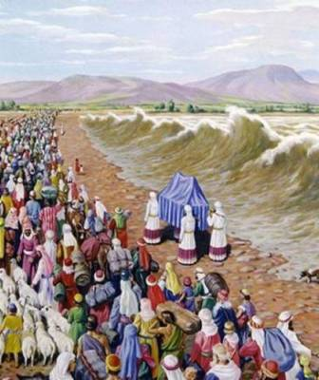
Joshua crosses the Jordan
Y'hoshua 3:14 And it came to pass, when the people removed from their tents, to pass over אֶת־ the Jordan, the priests that bare the Ark of the Covenant being before the people; 15 And when they that bare the Ark were come to the Jordan and the feet of the priests that bare the Ark were dipped in the brink of the water for the Jordan over flows all its banks during the time of harvest, 16 That the waters which came down from above stood and rose up in one heap, a great way off, at Adam, the city that is beside Zarethan; and those that went down toward the sea of the Arabah, even the Salt Sea, were completely cut off: and the people passed over right against Jericho. 17 And the priests that bare the Ark of the Covenant of יהוה stood firm on dry ground in the midst of the Jordan; and all Israel passed over on dry ground, until all the nation were passed clean over אֶת־ the Jordan. C-MATS
Y'hoshua 4:1 and it came to pass, when all the nation were clean passed over אֶת־ the Jordan, that יהוה spoke to Y'hoshua saying, 2 Take you twelve men out of the people, out of every tribe a man, 3 and command אֹותָם them saying, Take for yourself out of the midst of the Jordan, out of the place where the priests feet stood firm, twelve stones and carry אֹותָם them over with you and lay אֹותָם them down in the lodging-place, where you shall lodge this night. 4 Then Y'hoshua called the twelve men, who he had prepared of the Children of Israel, out of every tribe a man: 5 And Y'hoshua said to them, Pass over before the Ark of יהוה your Elohim into the midst of the Jordan and take up every man אֶחָת one stone upon his shoulder, according to the number of the tribes of the Children of Israel; 6 That may be זֹאת this a אֹות sign among you, when your children ask in time to come, saying, What did these stones mean to you? 7 Then you shall say to them, because the waters of the Jordan were cut off before the Ark of the Covenant of יהוה; when it passed over the Jordan, the waters of the Jordan were cut off: and these stones shall be for a memorial to the Children of Israel forever. C-MATS
12 stones

Y'hoshua 4:8 And the Children of Israel did so as Y'hoshua commanded and took up twelve stones out of the midst of the Jordan, as יהוה spoke to Y'hoshua, according to the number of the tribes of the Children of Israel; and they carried them over with them to the place where they lodged and laid them down there. 9 And Y'hoshua set up twelve stones in the midst of the Jordan, in the place where the feet of the priests that bare the Ark of the Covenant stood: and they are there to this day. 10 For the priests that bare the Ark stood in the midst of the Jordan, until was finished everything that commanded יהוה אֶת־ Y'hoshua to speak to the people, according to all that commanded Moses אֶת־ Y'hoshua: and the people hasted and passed over. 11 And it came to pass, when all the people were completely passed over, that the Ark of יהוה passed over and the priests, in the presence of the people. 12 And the children of Reuben and the children of Gad and the half-tribe of Manasseh, passed over armed before the Children of Israel, as Moses spoke to them: 13 About forty thousand ready armed for war passed over before יהוה to battle, to the plains of Jericho. 14 On that day magnified יהוה אֶת־ Y'hoshua in the sight of all Israel; and they feared אֹתֹו him, as they feared אֶת־ Moses, all the days of his life. 15 And יהוה spoke to Y'hoshua saying, 16 Command אֶת־ the priests that bear the Ark of the Testimony that they come up out of the Jordan. 17 Therefore, commanded Y'hoshua אֶת־ the priests, saying, Come up out of the Jordan. 18 And it came to pass, when the priests that bare the Ark of the Covenant of יהוה were come up out of the midst of the Jordan and the soles of the priests feet were lifted up to the dry ground, that the waters of the Jordan returned to their place and went over all its banks, as it did before. C-MATS

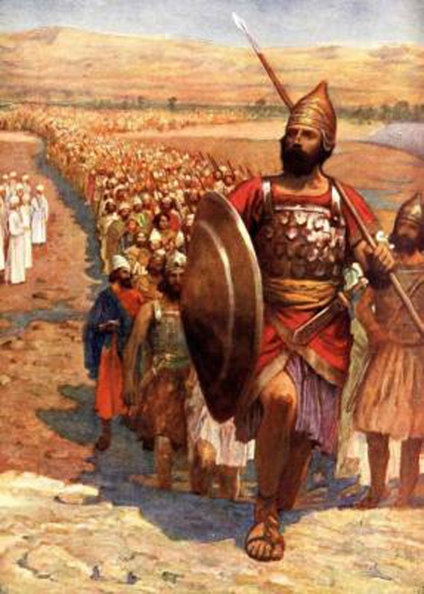
Joshua marches to Jericho

Y'hoshua 6:1 Now Jericho was straightly shut up because of the Children of Israel: none went out and none came in. 2 And יהוה said to Y'hoshua, See, I have given into your hand אֶת־ Jericho וְאֶת־ and the king there and the mighty men of valor. 3 And you shall compass אֶת־ the city, all the men of war, going about אֶת־ the city אֶחָת once. So shall you do six days. 4 And seven priests shall bear seven trumpets of ram’s horns before the Ark: and the seventh day you shall compass אֶת־ the city seven times and the priests shall blow the trumpets. 5 And it shall be, that, when they make a long blast with the ram’s horn and when you hear אֶת־ sound of the trumpet, all the people shall shout with a great shout; and the wall of the city shall fall down flat and the people shall go up every man straight before him. 6 And Y'hoshua the son of Nun called the priests and said to them, Take up אֶת־ the Ark of the Covenant and let seven priests bear seven trumpets of ram’s horns before the Ark of יהוה. 7 And they said to the people, Pass on and compass אֶת־ the city and let the armed men pass on before the Ark of יהוה. 8 And it was so, that, when Y'hoshua had spoken to the people, the seven priests bearing the seven trumpets of rams horns before יהוה passed on and blew the trumpets: and the Ark of the Covenant of יהוה followed them. 9 And the armed men went before the priests that blew the trumpets and the rear guard went after the Ark, the priests blowing the trumpets as they went. 10 וְאֶת־ and the people Y'hoshua commanded, saying, You shall not make any noise with אֶת־ your voice be heard, neither shall any word precede out of your mouth, until the day I bid you shout; then shall you shout. 11 So compass the Ark of יהוה אֶת־ to the city, going about it אֶחָת once: and they came into the camp and lodged in the camp. C-MATS
Y'hoshua 6:12 And Y'hoshua rose early in the morning and took up, the priest’s אֶת־ the Ark of יהוה. 13 And the seven priests bearing the seven trumpets of ram’s horns before the Ark of יהוה went on continually and blew the trumpets: and the armed men went before them; and the rear guard came after the Ark of יהוה, the priests blowing the trumpets as they went. 14 And the second day they compassed אֶת־ the city אֶחָת once and returned into the camp: so they did six days. 15 And it came to pass on the seventh day that they rose early at the dawning of the day and compassed אֶת־ the city after the same manner seven times: only on the day they compassed אֶת־ the city seven times. 16 And it came to pass at the seventh time, when the priests blew the trumpets, Y'hoshua said to the people, Shout; for יהוה has given you אֶת־ the city. 17 And the city shall be devoted, even it and all that is in it, to ליהוה: only Rahab the harlot shall live, she and all that are with אִתָּהּ her in the house, because she hid אֶת־ the messengers that we sent. 18 But as for אַתֶּם you, only keep yourselves from the accursed things, lest when you have taken of the accursed things you would make אֶת־ the camp of Israel accursed and trouble אֹותֹו it (him). 19 But all the silver and gold and vessels of brass and iron, are holy to ליהוה: they shall come into the treasury of יהוה. 20 So the people shouted and the priests blew the trumpets; and it came to pass, when hearing, the people אֶת־ sound of the trumpet that the people shouted with a great shout and the wall fell down flat, so that the people went up into the city, every man straight before him and they took אֶת־ the city. 21 And they utterly destroyed אֶת־ all that was in the city, both man and woman, both young and old and ox and sheep and donkey, with the edge of the sword. 22 And Y'hoshua said to the two men that had spied out אֶת־ the land, Go into the harlots house and bring out from there אֶת־ the woman וְאֶת־ and all that she has, as you swore to her. 23 And the young men that were spies went in and brought out אֶת־ Rahab, וְאֶת־ and her father וְאֶת־ and her mother וְאֶת־ and her brethren וְאֶת־ and all that she had; וְאֵת and all her kindred also they brought out; וְאֵת and all her kindred, set them outside the camp of Israel. 24 And they burned the city with fire and all that was in it; only the silver and the gold and the vessels of brass and of iron, they put into the treasury of the House of יהוה. 25 וְאֶת־ and Rahab the harlot וְאֶת־ and her father’s household וְאֶת־ and all that she had, did Y'hoshua save alive; and she lived in the midst of Israel to this day, because she hid אֶת־ the messengers, who Y'hoshua sent to spy out אֶת־ Jericho.
Y'hoshua 6:26 And Y'hoshua charged them with an oath at that time, saying, Cursed be the man before יהוה, that rises up and builds הַזֹּאת this אֶת־ city אֶת־ Jericho: with the loss of his first-born shall he lay the foundation there and with the loss of his youngest son shall he set up the gates of it. 27 So was יהוה אֶת־ with Y'hoshua; and his fame was in all the land. C-MATS

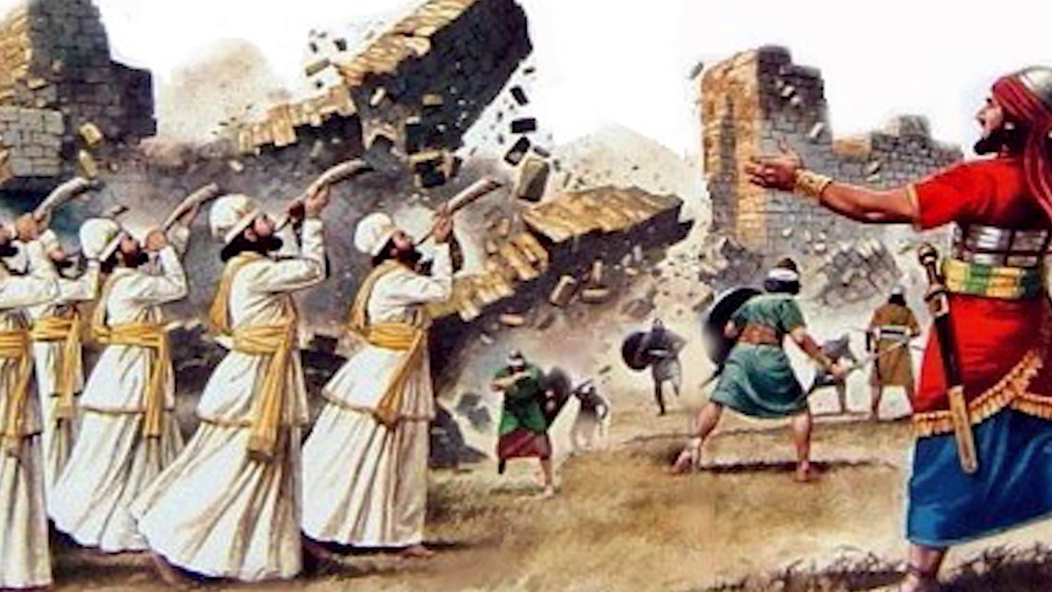
The walls of Jericho fall
Do You Know?

- The Israelites made a ___ with יהוה to keep all his commandments.
- The covenant the Israelites made with יהוה was for them and their ____. (who?)
- If you break יהוה’s commandments and do not repent, ____ will come upon you.
- If you are in exile, יהוה promises to bring you back to ____ in the last days. (where?)
- יהוה promises to ____ your heart so you can love יהוה with all your heart and soul.
- The commandments are not too ___ for you to keep.
- יהוה gives you a choice between blessings and ____
- יהוה asks you to choose ____ so you may live with יהוה forever.
- Moses was ____ years old when he died.
- יהוה wanted the laws read to the Israelites every ___ years during the Feast of Tabernacles.
- After Moses died, _____ led the Israelites across the Jordan River. (who?)
- The Levis priests carrying the ___ went before the Israelites as they crossed the Jordan River.
- One man from each tribe placed a ____ in the middle of the Jordan River as a memorial of what יהוה had done for them.
- ____ men were armed for battle when they crossed the Jordan River. (how many?)

Answers:
- covenant
- descendants
- curses
- Israel
- circumcise
- hard
- curses
- life
- 120
- 7
- Joshua
- Ark of the Covenant
- stone
- 40,000

"UP-BEAT TEMPO"
The normally plain-looking Saunder School lunchroom looked more like Symphony Hall. Kids holding all types of musical instruments -- from slender piccolos to massive brass tubas -- crowded around the long gray tables as they awaited their turn to try out for the all-school marching band.
Lisa Morris balanced her trombone on her lap as she reached into her red-and-white tote bag to pull out a can of soda and two plastic cups. "Want a drink? It's on me," she said cheerfully to her friend Marilyn who was sitting next to her.
But Marilyn didn't respond. She seemed in another world as she stared out into space through nervous eyes.
"Hey, are you in there?" Lisa quipped as she jokingly elbowed her friend in the shoulder.
Marilyn looked up. "Um, yeah, I mean no thanks," she said. "I'm too worried to drink."
"Worried? About what?" asked Lisa, scrunching up her eyebrows.
"Well, aren't you worried?" responded Marilyn. "This is our big chance to make the band, and I'm afraid I'm gonna blow it."
Lisa pointed to her friend's flute and said, "You had better 'blow' it or you definitely won't make it."
Marilyn laughed. "You know what I mean," she said. "I'm afraid I'll forget my song, or my flute will jam, or..."
"Everything will go great!" Lisa interrupted. "Listen Mar, you can sit and worry if you want, but when they call me, I intend to go in and try my best. That's all I can do. The rest is in God's hands. I think I play pretty well, but it's not up to me. Either way life will go on, so why worry?"
Marilyn nodded.
"One thing is for sure though," Lisa said, "being nervous won't help you play any better, and its likely to make things worse..."
"LISA MORRIS, NEXT PLEASE", crackled the voice over the intercom.
"Well, here I go. Wish me luck!" said Lisa as she ceremoniously marched toward the try-out room.
Marilyn smiled at her friend's antics. The girl took a deep breath and tried to relax as she waited for her turn.
A few moments later Marilyn heard her name being called. Instinctively she felt herself tense up as she walked toward the try-out room. But then she recalled her friend's words and attitude.
As she did, Marilyn felt her own worries begin to melt away. By the time she got to the door she felt almost calm and ready to give it her best shot.
Question: Does worrying help us reach our goal? Worrying wouldn't help us to reach our goals. You have the best chance if you try your hardest while trusting in יהוה. Worrying is an unproductive waste of energy.
Question: Are we really in control of whether we get nervous or not or does it just happen? There are some situations, such as taking a test where there is a lot on the line. It is only natural that in times like this we will feel tense or nervous, and that's okay. But we do have the ability to take control of that feeling and not let it carry us away. If we give ourselves positive messages that everything will work out for the best, and if we remember that יהוה is always by our side, we can really make many of these nervous feelings disappear.
Question: What is the difference between fear and worry? While the two feelings may be similar there are some crucial differences. Fear is a natural reaction to a genuine threatening or dangerous situation that exists in the present. It is the body's way of preparing itself for "fight or flight," to give it extra energy to face up to or escape from the situation. Worry tends to produce in us similar sensations when there is no immediate or real danger. Often it focuses on past events that no longer threaten us, or dwells on possible future problems (what if... etc.) which may never materialize. Whereas appropriate fear can be constructive and energizing, worry weakens us and makes us less effective.
Question: Is there a connection between a person's level of faith, or trust in יהוה, and his ability to stop worrying? Faith is a realization that we are not alone when facing challenges. We understand that יהוה is with us to help us deal with them successfully, and that He has also placed the challenge before us as an opportunity to grow. As long as we put in our best effort, we can rest assured that whatever results will be for our best. When we see things in this light, there is no longer any reason to worry, and life becomes much more manageable.
Philippians 4:6 Do not be anxious about anything, but in every situation, by prayer and petition, with thanksgiving, present your requests to Elohim. And the peace of Elohim, which transcends all understanding, will guard your hearts and your minds in Mashiach Yahusha
Isaiah 41:10 So do not fear, for I am with you; do not be dismayed, for I am your Elohim.
I will strengthen you and help you; I will uphold you with my righteous right hand.
Matthew 6:25 Therefore I tell you, do not worry about your life, what you will eat or drink; or about your body, what you will wear. Is not life more than food, and the body more than clothes? 32 for your heavenly Father knows that you have need of all these things. 33 But seek you first the kingdom of Elohim, and his righteousness; and all these things shall be added unto you. 34 Therefore do not worry about tomorrow, for tomorrow will worry about itself. Each day has enough trouble of its own.
Proverbs 12:25 Anxiety weighs down the heart, but a kind word cheers it up.
Ways to Stop Worrying:
Most of the things you worry about will never happen. If you look at the statistics of what scares people, you will find out that these things are unlikely to happen. Here are some statistics of common fear:
- Odds of being killed on a single airline flight 1 in 29.4 million
- Odds of becoming a lightning victim in any one year 1 in 700,000
- Odds of dying from contact with sharp objects 1 in 38,174
- Odds of dying from a cataclysmic storm 1 in 66,335

Odds of getting attacked by a shark 1 in 3,748,067

Odds of getting killed by fireworks 1 in 340,733

Odds of going blind after laser eye surgery 1 in 5 million
If you fear dying remember that the day of your death has already been decided, and nothing can change what day you will die. Psalm 138:16 Your eyes saw my unformed body; all the days ordained for me were written in your book before one of them came to be.
Don’t limit your life because you are afraid of death.

Feed Your Mind With the Right Food. What TV shows or news programs are you watching? What books are you reading? What was your last conversation with someone? The most recent thing you watch or read or hear is what your mind will focus on. Look for positive programming, documentaries, books, and people to talk to you. Leave the negative behind.
Philippians 4:8 Finally, brethren, whatsoever things are true, whatsoever things are honest, whatsoever things are just, whatsoever things are pure, whatsoever things are lovely, whatsoever things are of good report; if there be any virtue, and If there be any praise, think on these things. C-MATS

People don’t think about you and what you do as much as you may think. They have their hands full with thinking about what other people think of them. And with thinking about what is closest to their hearts like their children, pets, a partner or the job or school. So don’t get lost in worries about what people may think or say if you do something. Don’t let such thoughts hold you back or down in life. Proverbs 29:25 The fear of man brings a snare; but whoever puts his trust in ביהוה shall be safe. C-MATS

Talk about your worries with someone you trust. Sometimes when you verbalize your worries, they do not sound so threatening. Worries always are bigger in your thoughts than when put them into words. Loved ones can be a great source of support, providing you with empathy and understanding. Friends and family can also offer you valuable advice, giving you a different perspective on your problems. Pray with someone about your concerns.

Proverbs 19:20 Hear counsel and receive instruction, that you may be wise in your latter end. 21 There are many devices in a man’s heart; but the counsel of יהוה, that shall stand.

Proverbs 28:26 Whoever trusts in his own mind is a fool, but he who walks in wisdom will be delivered.

Accept that some things are beyond your control. Elohim is in control, and He knows what you and others need. No matter how much you try to solve problems, the outcomes will not always be the way you want them. 1 Thessalonians 5:16 Rejoice evermore. 17 Pray without ceasing. 18 In everything give thanks: for this is the will of Elohim in Mashiach Yahusha concerning you. Instead, focus your mind on the present things that you can deal with.

Channel your worries in different ways. When worries attack you, get a paper immediately and write them down. Brainstorm possible activities that can replace your worries.
- If you worry about failing a test, channel that energy into preparation for the test.
- If you worry about someone you love breaking up with you, channel that energy into improvement of the relationship.
- If you worry about negative feedbacks on the job, channel that energy into mastering your job or career.
- If you worry about getting sick, channel that energy into finding ways to build up your immune system.
- If you worry about dying, channel that energy into actually living your life as if it is your last day.
Isaiah 54:17 No weapon that is formed against you none will prosper; and every tongue that will rise אִתָּךְ against you in judgment you will condemn. זֹאת This is the heritage of the servants of יהוה and their righteousness is of Me, says יהוה. C-MATS
Write down your thoughts. If you do not have anyone you trust to talk to or you do not feel comfortable about sharing your worries, then use a journal to write down your thoughts. Journal writing is a powerful and effective way to get in touch with your inner self. By writing in a journal, you can work through your difficult emotions, uncover solutions to your issues, and change your perceptions and worries. Start with setting aside a time each day to write down your inner thoughts. You can focus on addressing each of your worries, writing them out as they come up, allowing yourself the freedom to fully express how you are feeling. End that time of journaling by giving each one of those worries to Elohim. 1 Peter 5:7 Cast all your anxiety on him because he cares for you.

Learn to relax. You cannot possibly feel anxious when you are in a state of relaxation. Learning to relax can be made easier through the use of relaxation techniques. These activities are geared towards helping you release tension throughout the body and let go of your worrisome thoughts. The next time you are consumed with worry, give one of these relaxation techniques a try:

- Progressive muscle relaxation
- Yoga
- Visualization
- Deep breathing
- Exercise
John 14:27 Peace I leave with you, my peace I give unto you: not as the world gives, give I unto you. Let not your heart be troubled, neither let it be afraid. C-MATS

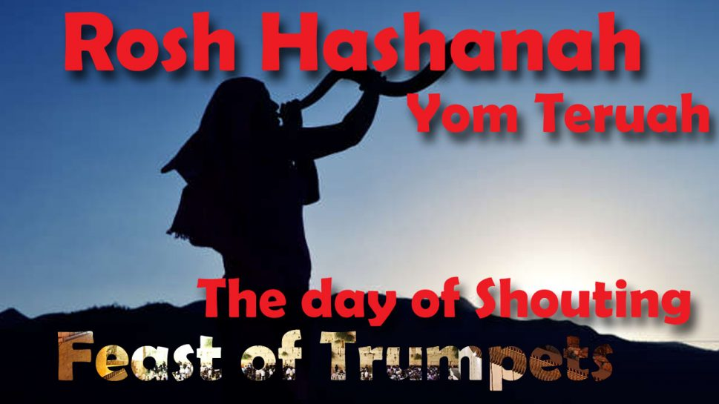

How to Celebrate the Biblical Feast Days by Debra Stuart Sanford

Question: How should you celebrate the Feast of Trumpets? Yom Teruah is the Hebrew name for the Feast of Trumpets which is translated “day of shouting/blasting.” This High Sabbath begins the 10 days preceding Yom Kippur. The sound of the shofar is intended to call the listener to awaken from his sin and beware of the coming judgment. This is a time for self-examination and repentance. This is a time to look back at the mistakes of the past year and plan to make changes for the next year.
1 Thessalonians 4:13 But I would not have you to be ignorant, brethren, concerning them which are asleep, that you sorrow not, even as others which have no hope. 14 For if we believe that Yahshua died and rose again, even so them also which sleep in Yahshua will Elohim bring with him. 15 For this we say to you by the word of יהוה, that we which are alive and remain to the coming of Adonai shall not prevent them which are asleep. 16 For Adonai shall descend from heaven with a shout, with the voice of the archangel, and with the trump of Elohim: and the dead in Mashiach shall rise first: 17 Then we which are alive and remain shall be caught up together with them in the clouds, to meet Adonai in the air: and so shall we ever be with יהוה. 18 Wherefore comfort one another with these words.
Question: When do you celebrate the Feast of Trumpets?

- YOU SHOULD CELEBRATE THE FEAST OF TRUMPETS ON THE FIRST DAY OF THE SEVENTH MONTH.

Leviticus 23:24 Speak to the Children of Israel saying, In the seventh month, on the first day of the month, you will have a Sabbath (Feast of Trumpets), a memorial of blowing of trumpets, a sacred convocation. C-MATS

Numbers 29:1 And in the seventh month, on the first day of the month (Rosh Hashanah), you will have a sacred convocation; you will do no ordinary work: it is a day of blowing the shofar for you. 2 And you will offer a burnt offering as a sweet savor to ליהוה. C-MATS

***The new moon (first day of seventh month) begins on September 7, 2021, so Rosh Hashanna begins on September 7th at sunset. September 8th is a High Sabbath.

Question: What commandments were given for the Feast of Trumpets?

- YOU SHOULD REST ON THE FEAST OF TRUMPETS.
- YOU SHOULD NOT WORK ON THE FEAST OF TRUMPETS.

Leviticus 23:24 Speak to the Children of Israel saying, In the seventh month, on the first day of the month, you will have a Sabbath (Feast of Trumpets), a memorial of blowing of trumpets, a sacred convocation. 25 You will do no ordinary work: but you will offer an offering made by fire to ליהוה. C-MATS

Numbers 29:1 And in the seventh month, on the first day of the month (Rosh Hashanah), you will have a sacred convocation; you will do no ordinary work: it is a day of blowing the shofar for you. 2 And you will offer a burnt offering as a sweet savor to ליהוה. C-MATS

- YOU SHOULD SOUND THE SHOFAR ON THE FEAST OF TRUMPETS.

Question: What is a shofar? The shofar is an instrument that makes a trumpet-like sound. It is usually made from a hollowed-out ram's horn, but it can also be made from the horn of a sheep or goat or any kosher animal.

Leviticus 23:24 Speak to the Children of Israel saying, In the seventh month, on the first day of the month, you will have a Sabbath (Feast of Trumpets), a memorial of blowing of trumpets, a sacred convocation. 25 You will do no ordinary work: but you will offer an offering made by fire to ליהוה. C-MATS

Numbers 29:1 And in the seventh month, on the first day of the month (Rosh Hashanah), you will have a sacred convocation; you will do no ordinary work: it is a day of blowing the shofar for you. 2 And you will offer a burnt offering as a sweet savor to ליהוה. C-MATS

- YOU SHOULD GIVE A VOLUNTATY OFFERING TO ELOHIM ON THE FEAST OF TRUMPETS.
Leviticus 23:24 Speak to the Children of Israel saying, In the seventh month, on the first day of the month, you will have a Sabbath (Feast of Trumpets), a memorial of blowing of trumpets, a sacred convocation. 25 You will do no ordinary work: but you will offer an offering made by fire to ליהוה. C-MATS

Numbers 29:1 And in the seventh month, on the first day of the month (Rosh Hashanah), you will have a sacred convocation; you will do no ordinary work: it is a day of blowing the shofar for you. 2 And you will offer a burnt offering as a sweet savor to ליהוה. C-MATS

Give to the poor at this time or a local charity that feeds the hungry. Be led by His Spirit as to where you should give your gift to Him.

Resources:
The Stone Edition of The Chumash
The Complete Messianic Aleph Tav Scriptures C-MATS www.AlephTavScriptures.com
“Weekly Torah Portion” from www.aish.com
How to Celebrate the Biblical Feast Days by Debra Stuart Sanford
Matthew Henry’s Bible Commentary

